DBMS LAB MANUAL

BY ANSH PATEL

|  |  |  |  |  |  |  |
| --- | --- | --- | --- | --- | --- | --- |
| **TABLE OF CONTENT** | | | | | | |
| **Sr. No** | **Experiment Title** | **Page No** | | **Date** | **Sign** | **Marks (out of 10)** |  |
| **Fro m** | **To** |
| **1.** | Basics of Database, Working with Excel &  MSAccess | **2** | **3** |  |  |  |
| **2.** | Working with SQL – DDL & DML Commands | **4** | **15** |  |  |  |
| **3.** | Simple Select Queries – Part-1 | **16** | **21** |  |  |  |
| **4.** | Simple Select Queries – Part-2 | **22** | **25** |  |  |  |
| **5.** | Select Queries using Like Operator | **26** | **28** |  |  |  |
| **6.** | Select Queries using SQL Functions | **29** | **31** |  |  |  |
| **7.** | Select Queries using Joins – Part-1 | **32** | **36** |  |  |  |
| **8.** | Select Queries using Joins – Part-2 | 37 | 42 |  |  |  |
| **9.** | Miscellaneous Practice Queries | 43 | 48 |  |  |  |
| **10.** | PL/SQL Programs | 49 | 51 |  |  |  |

**Practical-1**

Q.1 What is DBMS? Explain the advantages of DBMS over FPS.

🡪 DBMS stands for Database Management System. DBMS helps to maintain the data in tables and records which is more systematic than FPS (File Processing System). The advantages of DBMS over FPS are as follows:

1. Data redundancy and inconsistency.

2. Data sharing.

3. Data concurrency.

4. Data searching.

5. Data integrity.

6. Data security.

7. Data backup.

8. Easy maintenance.

Q.2 List 15 applications of the Database. Explain any 2 how Database can be helpful in managing that application.

🡪 The 15 applications of the Database are as follows:

1. Banking.

2. School (Students and Staff’s Details).

3. Human resources management.

4. Manufacturing Sector (Product Details).

5. Supermarket.

6. Library.

7. Railway Reservation System.

8. Credit Card Exchange.

9. Social Media Services.

10. Airline Reservation System.

11. Healthcare Sector.

12. Online Shopping.

13. Agriculture Fields.

14. Telecommunication Sector.

15. Military Purpose.

Railway and Airline Reservation System: It keeps the records of ticket bookings, arrival time, departure time, time delay, and even the seat no. of the airplane or train. Library Management System: There are thousands of books in the library, so it is very important to keep a record of the details of each book. Handwritten records can be proven a real hassle when we have to manage large no of books, using DBMS all the details of each book such as name, author’s name, number of pages, availability, quantity, etc., can be managed productively.

Q. 3 Create the database for following:=

Student Detail Using Excel.

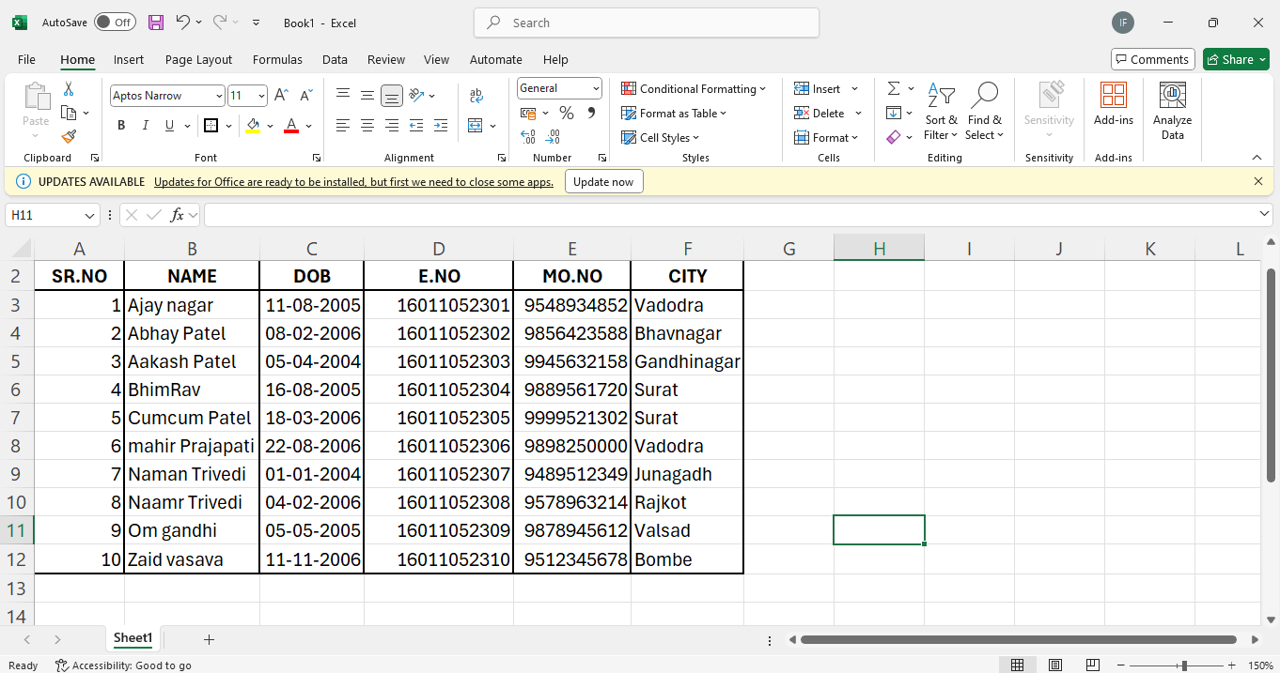

**Practical-2 Creat table**

**Q-2.1 Employees**

* CREATE TABLE Employees(E_name VARCHAR (15), Street VARCHAR (15), City VARCHAR (15));

INSERT INTO Employees(E_name, street, city)

Values ('Adam', 'Spring', 'Pittsfield');

INSERT INTO Employees(E_name, street, city)

Values ('Brooks', 'Scnator', 'Brooklyn’);

INSERT INTO Employees (E_name, street, city)

Values ('curry', 'North', 'Rye’);

INSERT INTO Employees(E_name, street, city)

Values ('Demalo', 'sunshini', 'San Deago');

SELECT*FROM Employees;

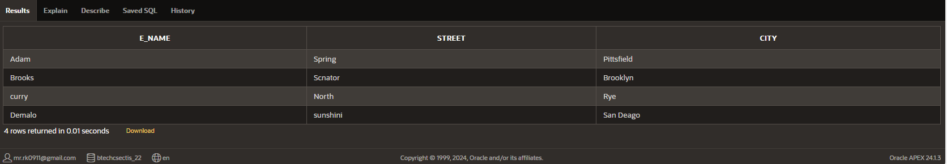

**Q-2.2 Work**

* CREATE TABLE Work(Emp_name VARCHAR (15), Cmp_name VARCHAR (15),Salary VARCHAR (15));

INSERT INTO Work(Emp_name, Cmp_name, salary)

Values ('Adam', 'FBC', '20000' );

INSERT INTO Work(Emp_name, Cmp_name, salary)

Values ('Brooks',‘30000’);

INSERT INTO Work(Emp_name, Cmp_name, salary)

Values ('Curry', 'SBC', ' 10000’);

SELECT*FROM Work;

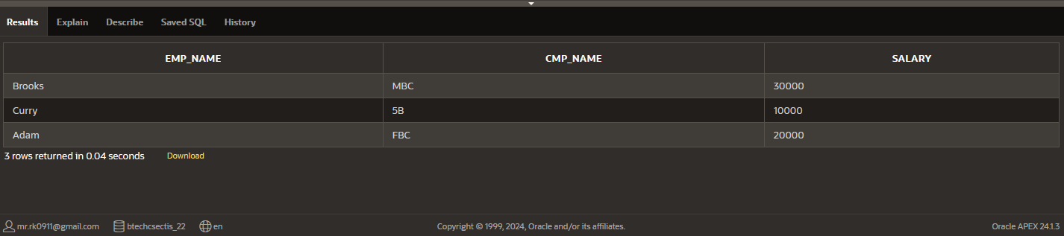

**Q-2.3 Company**

* CREATE TABLE Company (Cmp_name varchar(20),City varchar(20));

INSERT INTO Company (Cmp_name,City)

VALUES ('FBC','Pittsfield');

INSERT INTO Company (Cmp_name,City)

VALUES ('MBC','Brooklyn');

INSERT INTO Company (Cmp_name,City)

VALUES ('SBC','Rye');

SELECT*FROM Company;

**Q-2.4 Manager**

* CREATE TABLE Manager (Emp_name varchar(20), Man_name varchar(20));  
  INSERT INTO Manager (Emp_name, Man_name)  
  VALUES ('Adam', 'Smith');  
  INSERT INTO Manager (Emp_name, Man_name)  
  VALUES ('Brooks', 'Jones');  
  INSERT INTO Manager (Emp_name, Man_name)  
  VALUES ('Curry', 'Hayes');  
  SELECT*FROM Manager;

**Q-2.5 Sailors**

* CREATE TABLE Sailors (Sid varchar(20), Sname varchar(20), Rating varchar(20), Age varchar(20));  
  INSERT INTO Sailors (Sid, Sname, Ratings, Age)  
  VALUES ('22', 'Dustin', '7', '45.0');  
  INSERT INTO Sailors (Sid, Sname, Ratings, Age)  
  VALUES ('29', 'Brutus', '1', '33.0');  
  INSERT INTO Sailors (Sid, Sname, Ratings, Age)  
  VALUES ('31', 'Lubber', '8', '55.5');  
  INSERT INTO Sailors (Sid, Sname, Ratings, Age)  
  VALUES ('32', 'Andy', '8', '25.5');  
  INSERT INTO Sailors (Sid, Sname, Ratings, Age)  
  VALUES ('58', 'Rusty', '10', '35.0');  
  INSERT INTO Sailors (Sid, Sname, Ratings, Age)  
  VALUES ('64', 'Horatio', '7', '35.0');  
  INSERT INTO Sailors (Sid, Sname, Ratings, Age)  
  VALUES ('71', 'Zobra', '10', '16.0');  
  INSERT INTO Sailors (Sid, Sname, Ratings, Age)  
  VALUES ('74', 'Horation', '9', '35.0');  
  INSERT INTO Sailors (Sid, Sname, Ratings, Age)  
  VALUES ('85', 'Art', '3', '25.5');  
  INSERT INTO Sailors (Sid, Sname, Ratings, Age)  
  VALUES ('95', 'Bob', '3', '63.5');  
  SELECT*FROM Sailors;

**Q-2.6 Reserves**

* CREATE TABLE Reserves(Sid varchar(20),Bid varchar(20),Day varchar(300));

INSERT INTO RESERVES(Sid,Bid,Day)

VALUES ('22','101','10-OCT-98');

INSERT INTO RESERVES(Sid,Bid,Day)

VALUES ('22','102','10-OCT-98');

INSERT INTO RESERVES(Sid,Bid,Day)

VALUES ('22','103','10-AUG-98');

INSERT INTO RESERVES(Sid,Bid,Day)

VALUES ('22','104','10-JUL-98');

INSERT INTO RESERVES(Sid,Bid,Day)

VALUES ('31','102','11-OCT-98');

INSERT INTO RESERVES(Sid,Bid,Day)

VALUES ('31','103','11-JUN-98');

INSERT INTO RESERVES(Sid,Bid,Day)

VALUES ('31','104','11-DEC-98');

INSERT INTO RESERVES(Sid,Bid,Day)

VALUES ('64','101','9-MAY-98');

INSERT INTO RESERVES(Sid,Bid,Day)

VALUES ('64','102','9-AUG-98');

INSERT INTO RESERVES(Sid,Bid,Day)

VALUES ('74','103','9-AUG-98');

SELECT*FROM RESERVES;

**Q-2.7** **Boats**

* CREATE TABLE Boats(Bid varchar(20),Bname varchar(20),Color varchar(20));

INSERT INTO Boats(Bid,Bname, Color)

VALUES ('101','Interlake','Blue');

INSERT INTO Boats(Bid,Bname, Color)

VALUES ('102','Interlake','Red');

INSERT INTO Boats(Bid,Bname, Color)

VALUES ('103','Clipper','Green');

INSERT INTO Boats(Bid,Bname, Color)

VALUES ('104','Marine','Red');

SELECT*FROM Boats;

**Q-2.8** **Client**

* CREATE TABLE Client (Cl_no varchar(20),Name varchar(30),City varchar(20),Pincode varchar(20),State varchar(20),Baldue varchar(20));

INSERT INTO Client (Cl_no,Name,City,Pincode,State,Baldue)

VALUES ('C00001','Ivan Bayross','Mumbai','400054','Maharashtra','15000');

INSERT INTO Client (Cl_no,Name,City,Pincode,State,Baldue)

VALUES ('C00002','Mamta Muzumdar','Madras','780001','Tamil Nadu','100');

INSERT INTO Client (Cl_no,Name,City,Pincode,State,Baldue)

VALUES ('C00003','Chhaya Bankar','Mumbai','400057','Maharashtra','5000');

INSERT INTO Client (Cl_no,Name,City,Pincode,State,Baldue)

VALUES ('C00004','Ashwini Joshi','Bangalore','560001','Karnataka','2000');

INSERT INTO Client (Cl_no,Name,City,Pincode,State,Baldue)

VALUES ('C00005','Hansel Colaco','Mumbai','400060','Maharashtra','2000');

INSERT INTO Client (Cl_no,Name,City,Pincode,State,Baldue)

VALUES ('C00006','Deepak Sharma','Mangalore','560050','Karnataka','1000');

SELECT*FROM Client;

**Q-2.9 Product**

* CREATE TABLE Product (Pr_no varchar(20),Dscr varchar(20),Profit varchar(20),Unit varchar(20),Qty varchar(30),Reorder_lv1 varchar(30),Sell_price varchar(20),Cost_Price varchar(20));

INSERT INTO Product (Pr_no,Dscr,Profit,Unit,Qty,Reorder_lv1,Sell_price,Cost_Price)

VALUES ('P00001','T-Shirts','5','Piece','200','50','350','250');

INSERT INTO Product (Pr_no,Dscr,Profit,Unit,Qty,Reorder_lv1,Sell_price,Cost_Price)

VALUES ('P0345','Shirts','6','Piece','250','50','500','350');

INSERT INTO Product (Pr_no,Dscr,Profit,Unit,Qty,Reorder_lv1,Sell_price,Cost_Price)

VALUES ('P06734','Cotton Jeans','5','Piece','100','20','600','450');

INSERT INTO Product (Pr_no,Dscr,Profit,Unit,Qty,Reorder_lv1,Sell_price,Cost_Price)

VALUES ('P07865','Jeans','5','Piece','100','20','750','500');

INSERT INTO Product (Pr_no,Dscr,Profit,Unit,Qty,Reorder_lv1,Sell_price,Cost_Price)

VALUES ('P07868','Trousers','2','Piece','150','50','850','550');

INSERT INTO Product (Pr_no,Dscr,Profit,Unit,Qty,Reorder_lv1,Sell_price,Cost_Price)

VALUES ('P07885','Pull Overs','3','Piece','80','30','700','750');

INSERT INTO Product (Pr_no,Dscr,Profit,Unit,Qty,Reorder_lv1,Sell_price,Cost_Price)

VALUES ('P07965','Denim Shirts','4','Piece','100','40','350','250');

INSERT INTO Product (Pr_no,Dscr,Profit,Unit,Qty,Reorder_lv1,Sell_price,Cost_Price)

VALUES ('P07975','Lycra Tops','5','Piece','70','30','300','175');

INSERT INTO Product (Pr_no,Dscr,Profit,Unit,Qty,Reorder_lv1,Sell_price,Cost_Price)

VALUES ('P08865','Skirts','5','Piece','75','30','450','300');

SELECT*FROM Product;

**Q-2.10 Salesman**

* CREATE TABLE Salesman (Sl_no varchar(20),Name varchar(20),Add1 varchar(30),Add2 varchar(20),City varchar(20),Pin varchar(30),State varchar(20),Amt varchar(20), Tgt varchar(20), Sales varchar(20), Rem varchar(20));

INSERT INTO Salesman (Sl_no, Name, Add1, Add2, City, Pin, State, Amt, Tgt, Sales, Rem)

VALUES('S00001','Aman','A/14','Worli','Mumbai','400002','Maharastra','3000','100','50','Good');

INSERT INTO Salesman (Sl_no, Name, Add1, Add2, City, Pin, State, Amt, Tgt, Sales, Rem)

VALUES('S00002','Omkar','65','Nariman','Mumbai','400001','Maharastra','3000','200','100','Good');

INSERT INTO Salesman (Sl_no, Name, Add1, Add2, City, Pin, State, Amt, Tgt, Sales, Rem)

VALUES('S00003','Raj','P7','Bandra','Mumbai','400032','Maharastra','3000','200','100','Good');

INSERT INTO Salesman (Sl_no, Name, Add1, Add2, City, Pin, State, Amt, Tgt, Sales, Rem)

VALUES('S00004','Ashish','A/5','Juhu','Mumbai','400042','Maharastra','3000','200','150','Good');

SELECT*FROM Salesman;

**Q-2.11 Salesorder**

* CREATE TABLE Salesorder (Od_no varchar(20),Cl_no varchar(20),O_data varchar(20),Sl_no varchar(20),D_type varchar(30),Bill varchar(20),D_dat varchar(20),Status varchar(20));

INSERT INTO Salesorder (Od_no, Cl_no, O_data, Sl_no, D_type, Bill, D_dat, Status)

VALUES ('O19001','C00001','12-JUN-04','S00001','F','N','20-JUL-04','In Process');

INSERT INTO Salesorder (Od_no, Cl_no, O_data, Sl_no, D_type, Bill, D_dat, Status)

VALUES ('O19002','C00002','25-JUN-04','S00002','P','N','27-JUL-04','Cancelled');

INSERT INTO Salesorder (Od_no, Cl_no, O_data, Sl_no, D_type, Bill, D_dat, Status)

VALUES ('O46865','C00003','18-FEB-04','S00003','F','Y','20-FEB-04','Fulfilled');

INSERT INTO Salesorder (Od_no, Cl_no, O_data, Sl_no, D_type, Bill, D_dat, Status)

VALUES ('O19003','C00001','03-APR-04','S00001','F','Y','07-APR-04','Fulfilled');

INSERT INTO Salesorder (Od_no, Cl_no, O_data, Sl_no, D_type, Bill, D_dat, Status)

VALUES ('O46866','C00004','20-MAY-04','S00002','P','N','22-MAY-04','Cancelled');

INSERT INTO Salesorder (Od_no, Cl_no, O_data, Sl_no, D_type, Bill, D_dat, Status)

VALUES ('O19008','C00005','25-MAY-04','S00041','F','N','26-JUL-04','In Process');

SELECT*FROM Salesorder;

**Q-2.12 Salesorder_Details**

* CREATE TABLE Salesorder_Details (Od_no varchar(30),Pr_no varchar(20),Qty_order varchar(20),Qty_disp varchar(20),Rate varchar(20));

INSERT INTO Salesorder_Details (Od_no, Pr_no, Qty_order, Qty_disp, Rate)

VALUES ('O19001','P00001','4','4','525');

INSERT INTO Salesorder_Details (Od_no, Pr_no, Qty_order, Qty_disp, Rate)

VALUES ('O19001','P07965','2','1','8400');

INSERT INTO Salesorder_Details (Od_no, Pr_no, Qty_order, Qty_disp, Rate)

VALUES ('O19001','P07885','2','1','5250');

INSERT INTO Salesorder_Details (Od_no, Pr_no, Qty_order, Qty_disp, Rate)

VALUES ('O19002','P00001','10','0','525');

INSERT INTO Salesorder_Details (Od_no, Pr_no, Qty_order, Qty_disp, Rate)

VALUES ('O46865','P07868','3','3','3150');

INSERT INTO Salesorder_Details (Od_no, Pr_no, Qty_order, Qty_disp, Rate)

VALUES ('O46265','P07885','3','1','5250');

INSERT INTO Salesorder_Details (Od_no, Pr_no, Qty_order, Qty_disp, Rate)

VALUES ('O46865','P00001','10','10','525');

INSERT INTO Salesorder_Details (Od_no, Pr_no, Qty_order, Qty_disp, Rate)

VALUES ('O46865','P0345','4','4','1050');

INSERT INTO Salesorder_Details (Od_no, Pr_no, Qty_order, Qty_disp, Rate)

VALUES ('O19003','P0345','2','2','1050');

INSERT INTO Salesorder_Details (Od_no, Pr_no, Qty_order, Qty_disp, Rate)

VALUES ('O19003','P06734','1','1','12000');

INSERT INTO Salesorder_Details (Od_no, Pr_no, Qty_order, Qty_disp, Rate)

VALUES ('O46866','P07965','1','0','8400');

INSERT INTO Salesorder_Details (Od_no, Pr_no, Qty_order, Qty_disp, Rate)

VALUES ('O46866','P07975','1','0','1050');

INSERT INTO Salesorder_Details (Od_no, Pr_no, Qty_order, Qty_disp, Rate)

VALUES ('O19008','P00001','10','5','525');

INSERT INTO Salesorder_Details (Od_no, Pr_no, Qty_order, Qty_disp, Rate)

VALUES ('O19008','P07975','5','3','1050');

SELECT*FROM Salesorder_Details;

**Q-2.13 Deposit**

* CREATE TABLE Deposit (Act_no varchar(20),Cname varchar(20),Bname varchar(20),Amount varchar(20),Date_ varchar(20));

INSERT INTO Deposit (Act_no,Cname,Bname,Amount,Date_)

VALUES ('100','ANIL','VRCE','1000.00','1-MAR-95');

INSERT INTO Deposit (Act_no,Cname,Bname,Amount,Date_)

VALUES ('101','SUNILL','AJNI','5000.00','4-JAN-96');

INSERT INTO Deposit (Act_no,Cname,Bname,Amount,Date_)

VALUES ('102','MEHUL','KAROLBAGH','3500.00','17-NOV-95');

INSERT INTO Deposit (Act_no,Cname,Bname,Amount,Date_)

VALUES ('104','MADHURI','CHANDI','1200.00','17-DEC-95');

INSERT INTO Deposit (Act_no,Cname,Bname,Amount,Date_)

VALUES ('105','PRMOD','M.G.ROAD','3000.00','27-MAR-96');

INSERT INTO Deposit (Act_no,Cname,Bname,Amount,Date_)

VALUES ('106','SANDIP','ANDHERI','2000.00','31-MAR-96');

INSERT INTO Deposit (Act_no,Cname,Bname,Amount,Date_)

VALUES ('107','SHIVANI','VIRAR','1000.00','5-SEP-95');

INSERT INTO Deposit (Act_no,Cname,Bname,Amount,Date_)

VALUES ('108','KRANTI','NEHRU PLACE','5000.00','2-JUL-95');

INSERT INTO Deposit (Act_no,Cname,Bname,Amount,Date_)

VALUES ('109','MINU','POWAI','7000.00','10-AUG-95');

SELECT*FROM Deposit;

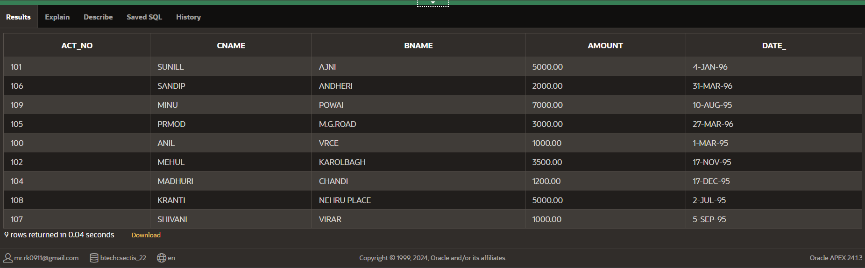

**Q-2.14 Borrow**

* CREATE TABLE Borrow (Loan_no varchar(20),Cname varchar(20),Bname varchar(20),Amount varchar(20));

INSERT INTO Borrow(Loan_no, Cname, Bname, Amount)

VALUES ('201', 'ANIL', 'VRCE','1000.00');

INSERT INTO Borrow(Loan_no, Cname, Bname, Amount)

VALUES ('206', 'MEHUL', 'AJNI','5000.00');

INSERT INTO Borrow(Loan_no, Cname, Bname, Amount)

VALUES ('311', 'SUNIL', 'DHARAMPETH','3000.00');

INSERT INTO Borrow(Loan_no, Cname, Bname, Amount)

VALUES ('321', 'MADHURI', 'ANDHERI','2000.00');

INSERT INTO Borrow(Loan_no, Cname, Bname, Amount)

VALUES ('375', 'PROMOD', 'VIRAR','8000.00');

INSERT INTO Borrow(Loan_no, Cname, Bname, Amount)

VALUES ('481', 'KRANTI', 'NEHRU PLACE','3000.00');

SELECT*FROM Borrow;

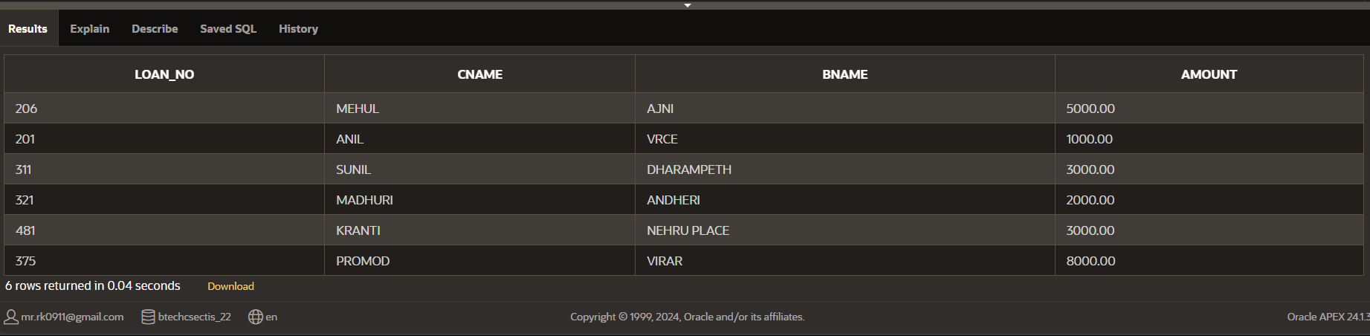

**Q-2.15 Branch**

* CREATE TABLE Branch(Bname Varchar(20), City varchar(20));

INSERT INTO Branch(Bname, City)

VALUES ('VRCE', 'NAGPUR');

INSERT INTO Branch(Bname, City)

VALUES ('AJNI', 'NAGPUR');

INSERT INTO Branch(Bname, City)

VALUES ('KAROLBAGH', 'DELHI');

INSERT INTO Branch(Bname, City)

VALUES ('CHANDI', 'DELHI');

INSERT INTO Branch(Bname, City)

VALUES ('DHARAMPETH', 'NAGPUR');

INSERT INTO Branch(Bname, City)

VALUES ('M.G.ROAD', 'BANGLORE');

INSERT INTO Branch(Bname, City)

VALUES ('ANDHERI', 'BOMBAY');

INSERT INTO Branch(Bname, City)

VALUES ('VIRAR', 'BOMBAY');

INSERT INTO Branch(Bname, City)

VALUES ('NEHRU PLACE', 'DELHI');

INSERT INTO Branch(Bname, City)

VALUES ('POWAI', 'BOMBAY');

SELECT*FROM Branch;

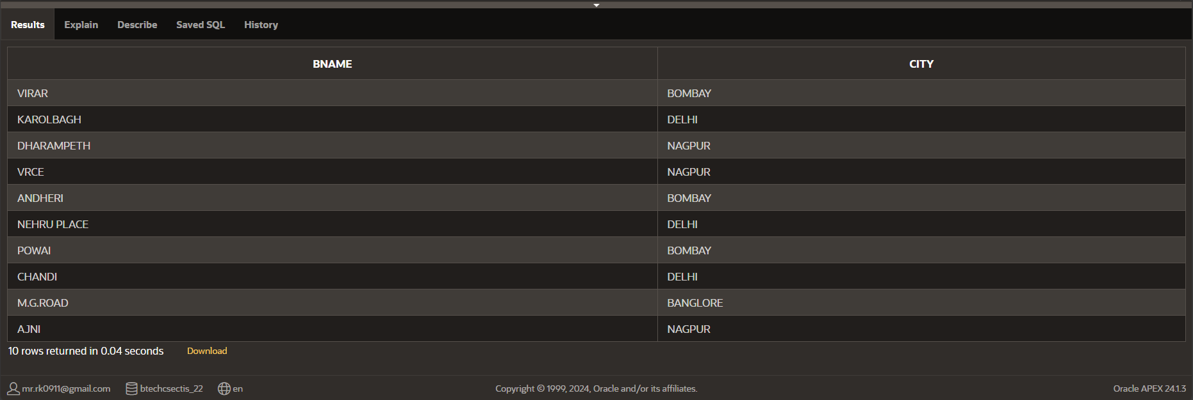

**Q-2.16 Customers**

* CREATE TABLE Customers(Cname Varchar(20), City varchar(20));

INSERT INTO Customers(Cname, City)

VALUES ('ANIL', 'CALCUTTA');

INSERT INTO Customers(Cname, City)

VALUES ('SUNIL', 'DELHI');

INSERT INTO Customers(Cname, City)

VALUES ('MEHUL', 'BARODA');

INSERT INTO Customers(Cname, City)

VALUES ('MANDAR', 'PATNA');

INSERT INTO Customers(Cname, City)

VALUES ('MADHURI', 'NAGPUR');

INSERT INTO Customers(Cname, City)

VALUES ('PRAMOD', 'NAGPUR');

INSERT INTO Customers(Cname, City)

VALUES ('SANDIP', 'SURAT');

INSERT INTO Customers(Cname, City)

VALUES ('SHIVANI', 'BOMBAY');

INSERT INTO Customers(Cname, City)

VALUES ('KRANTI', 'BOMDAY');

INSERT INTO Customers(Cname, City)

VALUES ('NAREN', 'BOMBAY');

SELECT*FROM Customers;

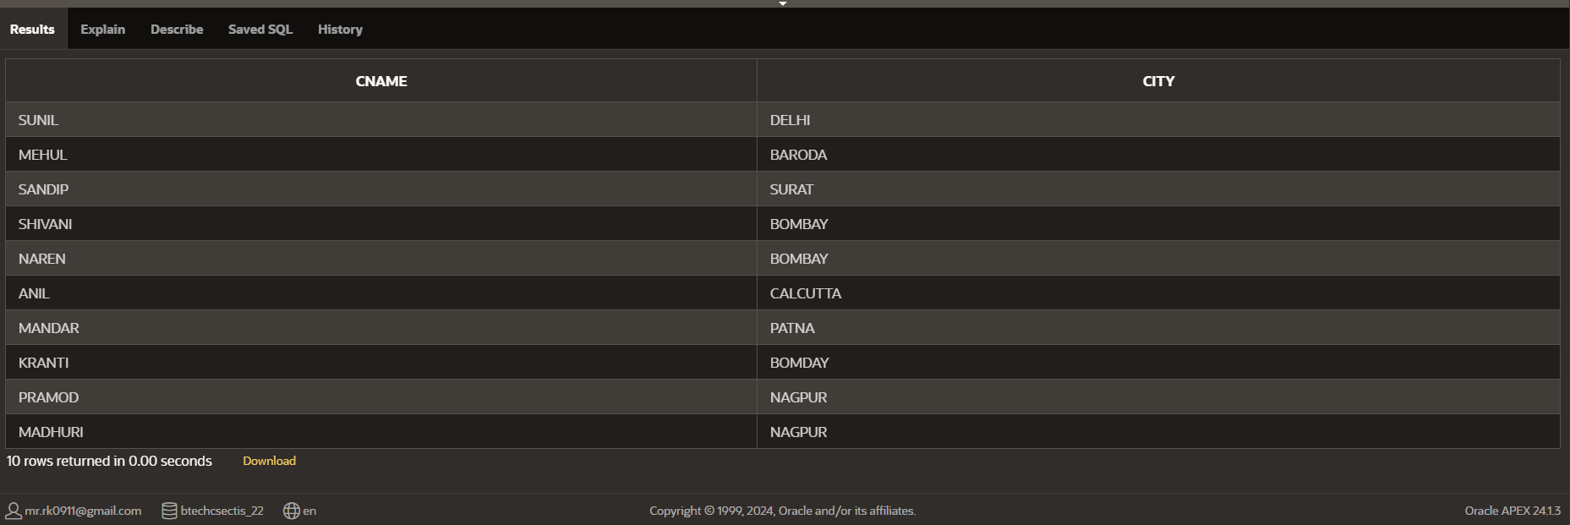

**Practical-3 Simple Queries**

**Q-3.1 Describe deposit, branch.**

* a) DESC DEPOSIT;

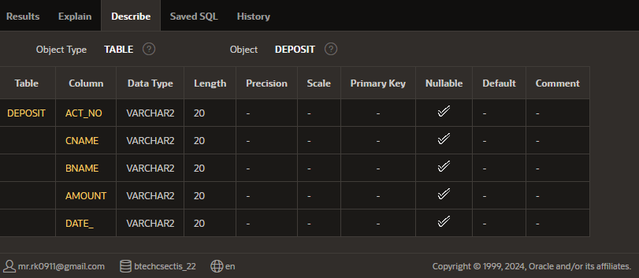

b) DESC BRANCH;

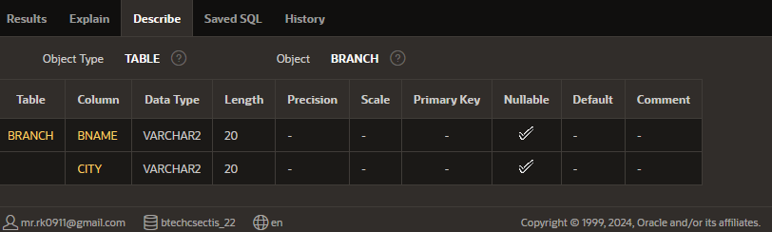

**Q-3.2 Describe borrow, customers**

* a) DESC BORROW;

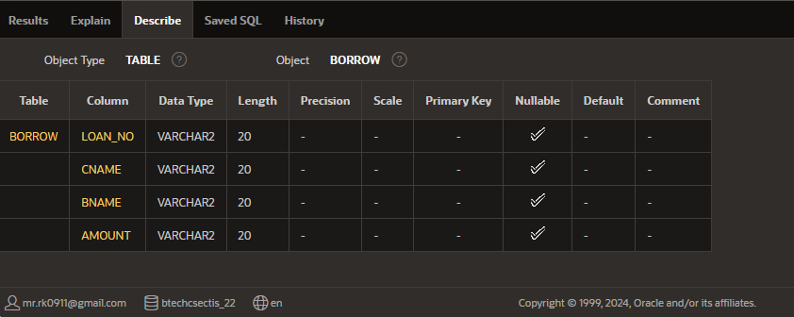

b) DESC CUSTOMER;

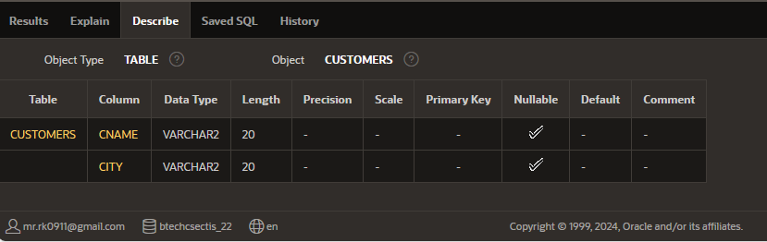

**Q-3.3 List all data**

* SELECT*FROM DEPOSIT;

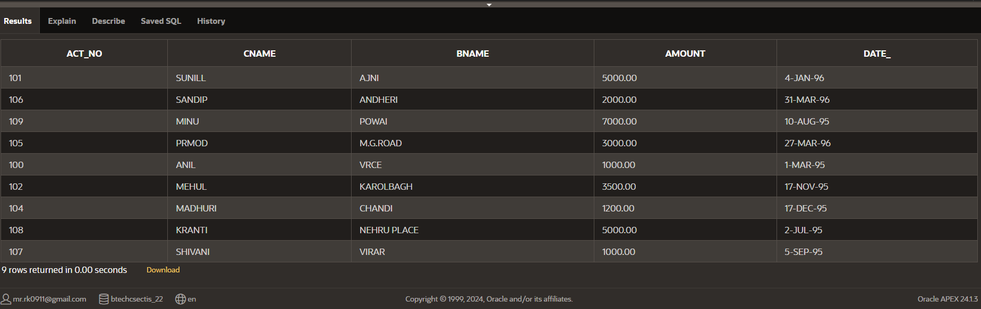

**Q-3.4 List all data from table Borrow**

* SELECT*FROM BORROW;

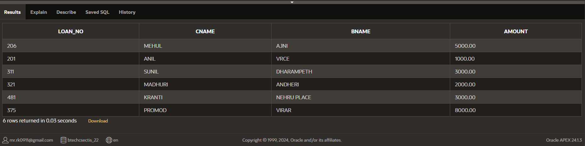

**Q-3.5 List all data from table Customers**

* SELECT*FROM CUSTOMERS;

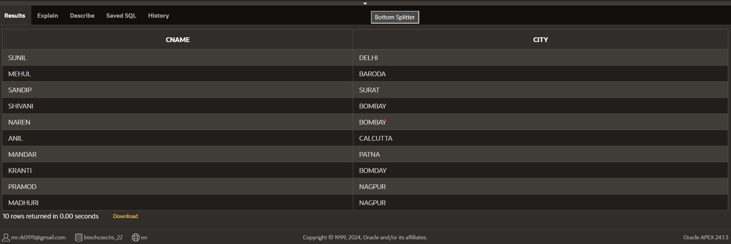

**Q-3.6 List all data from table Branch.**

* SELECT*FROM BRANCH;

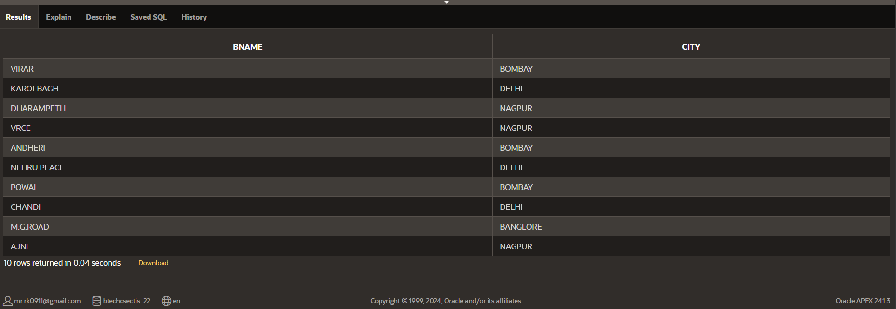

**Q-3.7 Give account no and amount of Depositors**

* SELECT ACT_NO,AMOUNT FROM DEPOSIT;

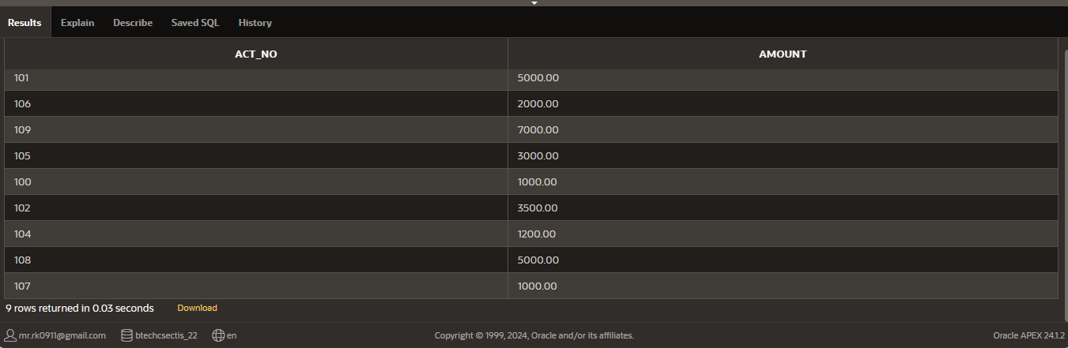

**Q-3.8 List all data from Sailors**

* a)SELECT*FROM SAILORS;

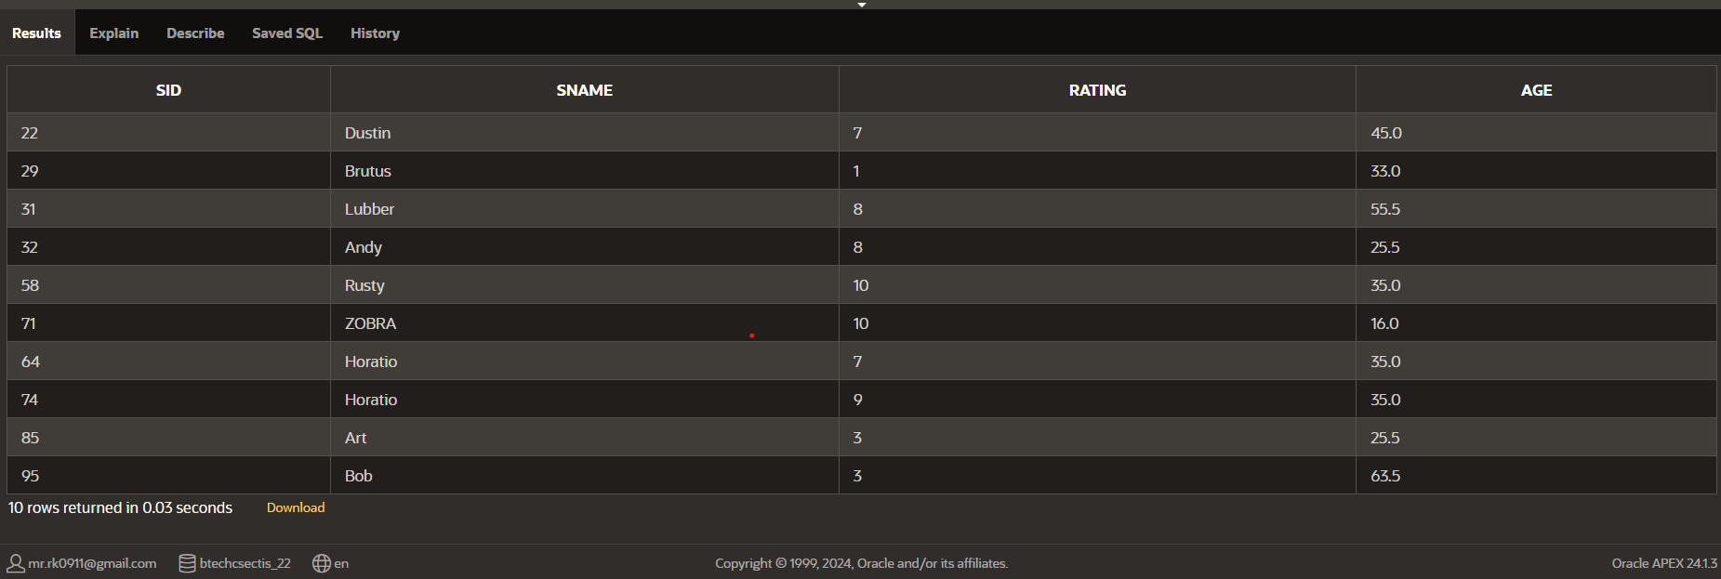

**Q-3.8 List boat name ad its color**

* b) SELECT BNAME,COLOR FROM BOATS;

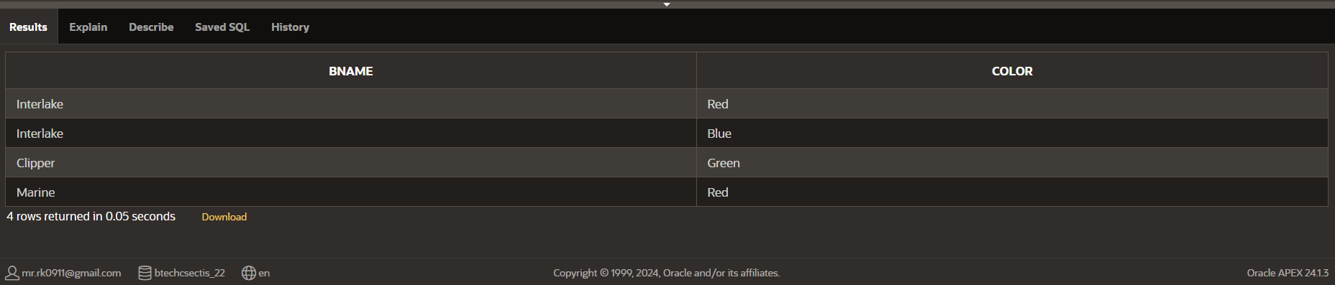

**Q-3.9 List employee name and its city**

* SELECT E_NAME,CITY FROM EMPLOYEES;

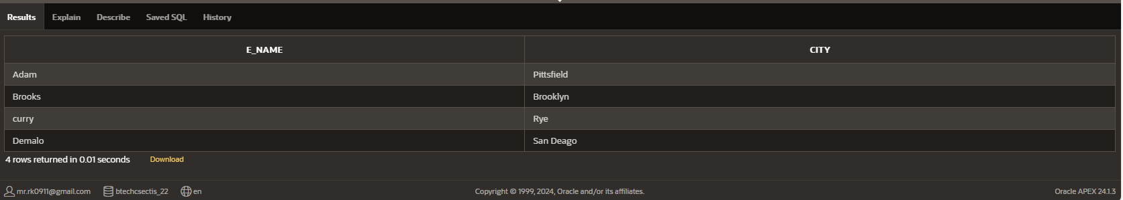

**Q-3.10 List all details pf client**

* SELECT*FROM CLIENT;

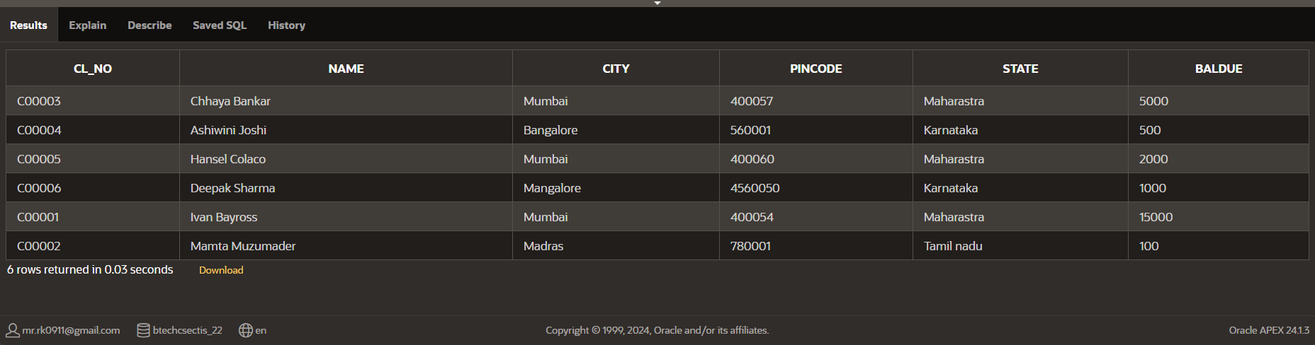

**Q-3.11 Describe various products and its price**

* SELECT SELL_PRICE,COST_PRICE FROM PRODUCT;

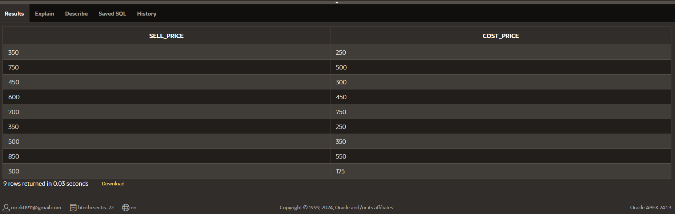

**Q-3.12 Describe sailors name, age and its rating.**

* SELECT SNAME,AGE,RATING FROM SAILORS;

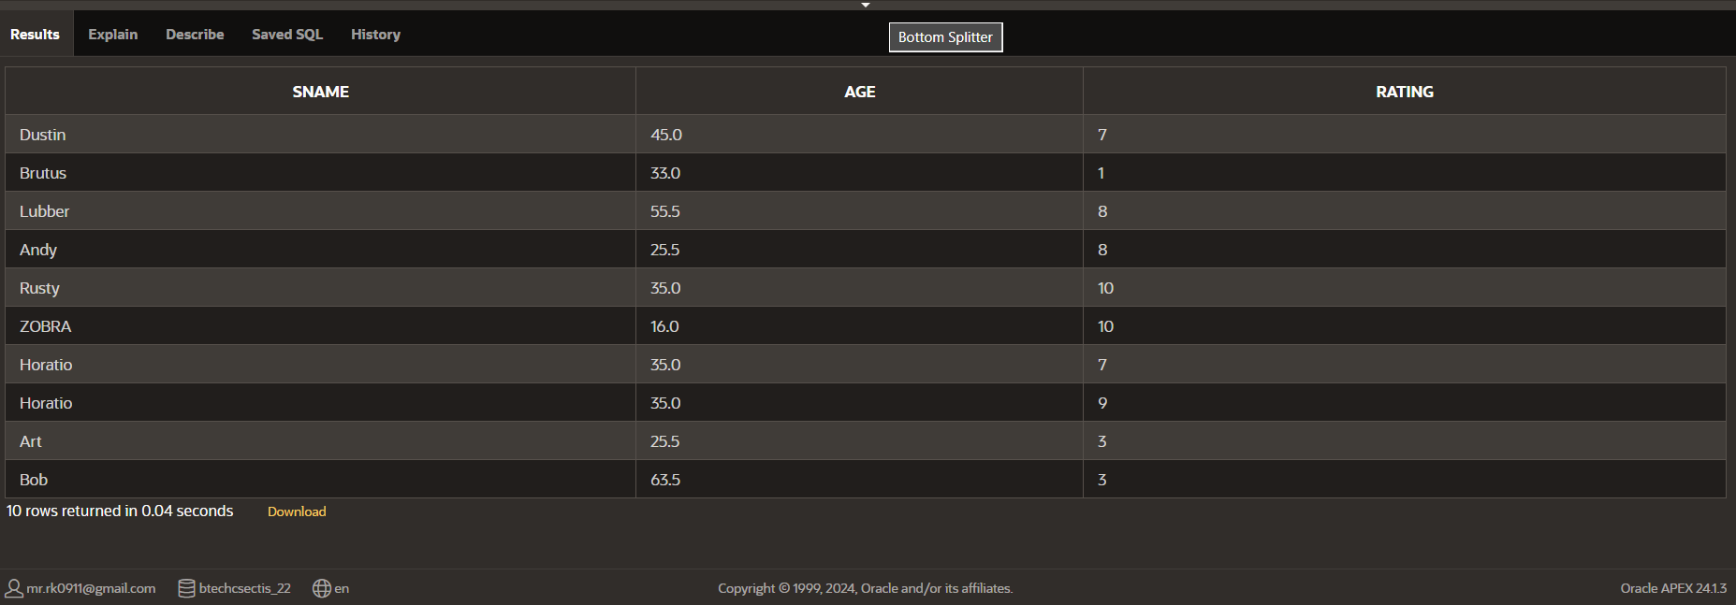

**Q-3.13 Describe the managers of various employees**

* SELECT *FROM MANAGER;

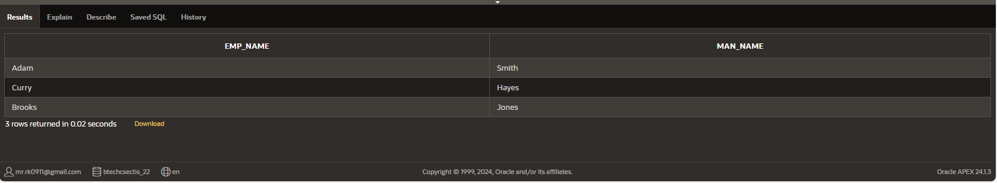

**Q-3.14 Describe the details of loan for customers.**

* SELECT LOAN_NO,BNAME,AMOUNT FROM BORROW;

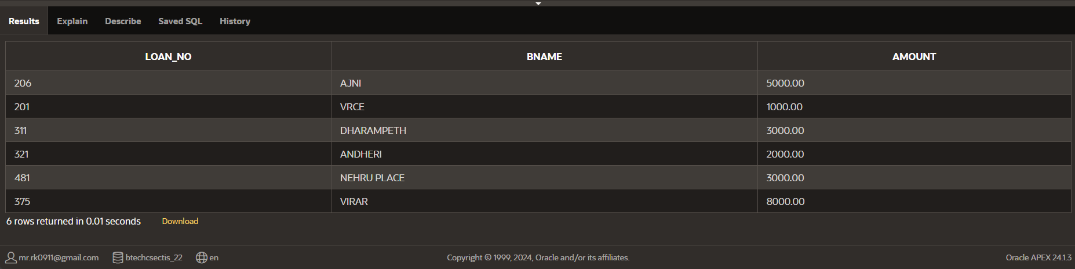

**Q-3.15 Describe the date of travel of various sailors.**

* SELECT DAY FROM RESERVES;

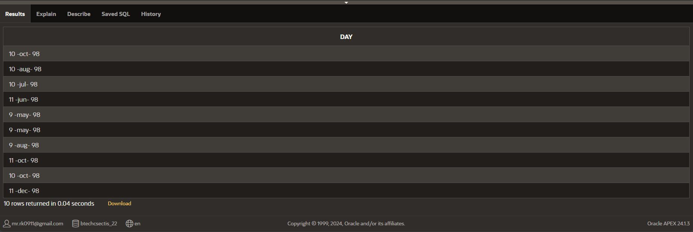

**Practical-4 Simple Queries**

**Q-4.1 Give name of Depositors having amount greater than 4000.**

* SELECT cname FROM deposit WHERE AMOUNT>4000;

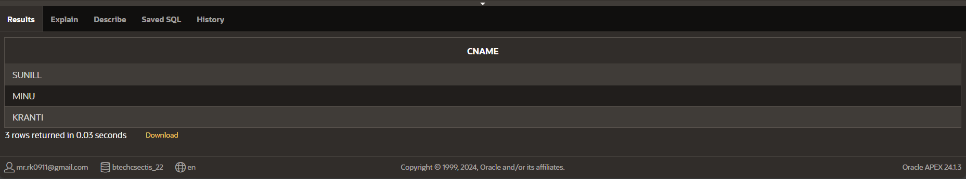

**Q-4.2 List the employees having salary less than 2200.**

* SELECT EMP_NAME FROM WORK WHERE SALARY<22000;

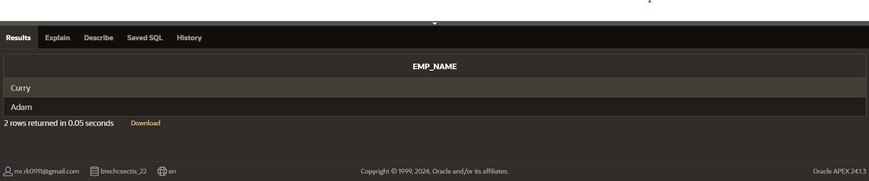

**Q-4.3 List the sailors having age more than 25**

* SELECT SNAME FROM SAILORS WHERE AGE>25;

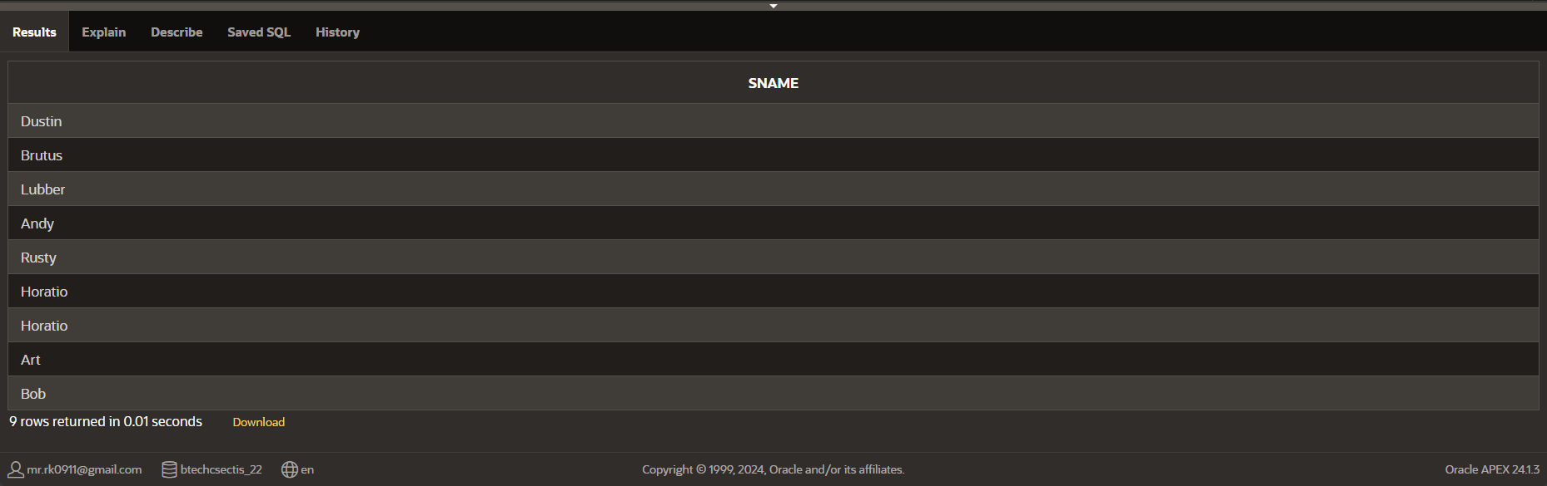

**Q-4.4 List the boats travelling on 10-oct-98**

* SELECT bid,day FROM reserves WHERE day = '10 -oct- 98';

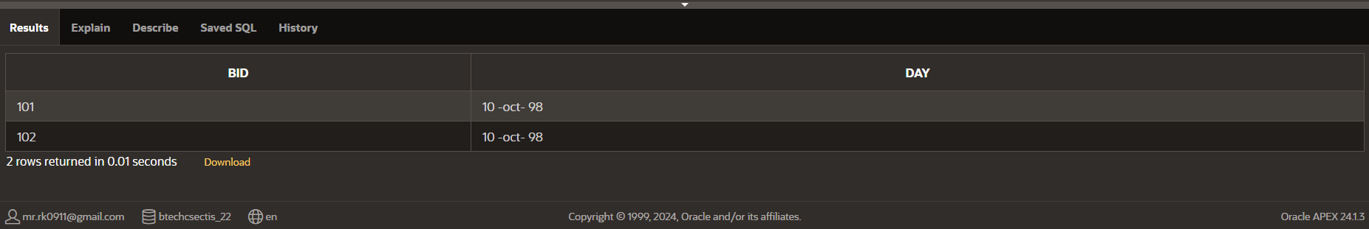

**Q-4.5 List the details of boat “Interlake”.**

* SELECT *FROM Boats WHERE Bname='Interlake';

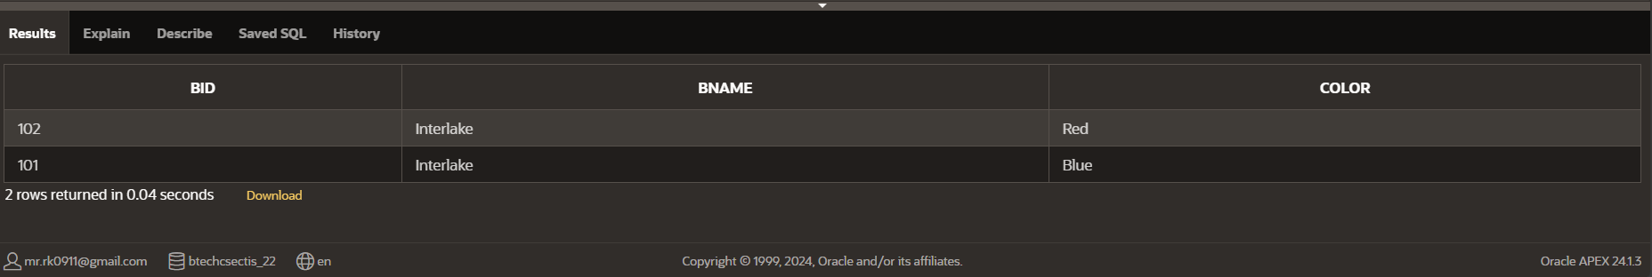

**Q-4.6 List the details of red colored boat**

* SELECT *FROM Boats WHERE Color='Red';

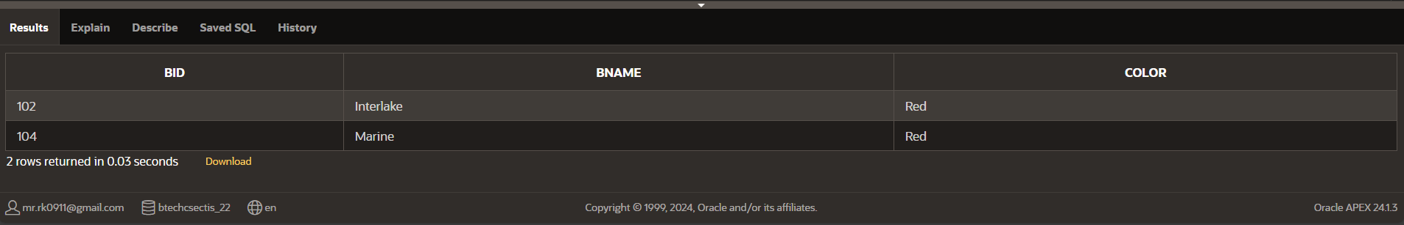

**Q-4.7 List the details of client whose city is Mumbai**

* SELECT*FROM Client WHERE City='Mumbai';

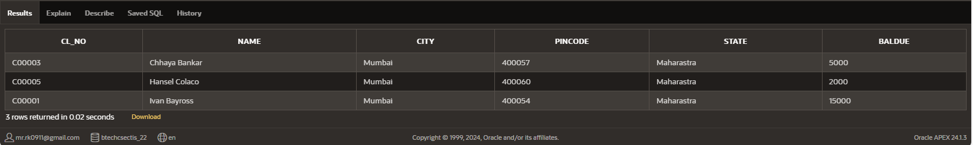

**Q-4.8 List client name,due balance and city of the clients having balance greater than 1500**

* SELECT Name,Baldue,City FROM Client WHERE Baldue>1500;

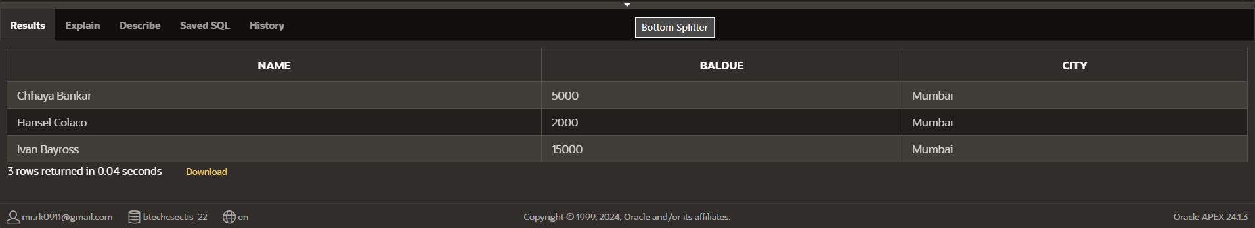

**Q-4.9 Describe the details of products having sell price less than 500**

* SELECT Pr_no FROM Product WHERE Sell_Price<500;

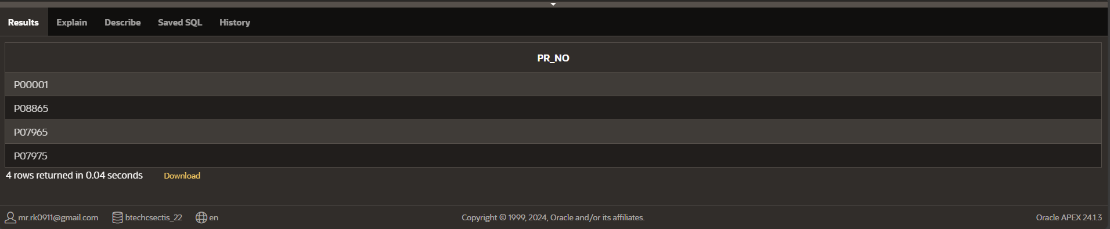

**Q-4.10 List the products for which quantity ordered is less then 120 and cost price is greater than 250**

* SELECT*FROM Product WHERE Qty<120 and Cost_price>250;

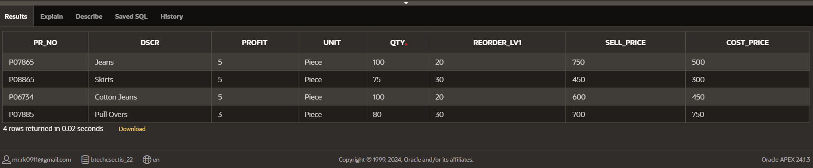

**Q-4.11 Display account details having amount greater than 2200**

* SELECT*FROM Deposit WHERE Amount > 2200;

**Q-4.12 Display all customers staying in Nagpur.**

* SELECT *FROM Customers WHERE City ='NAGPUR';

**Q-4.13 Display the name of sailors having rating greater than 7.**

* SELECT Sname FROM Sailors WHERE Rating>7;

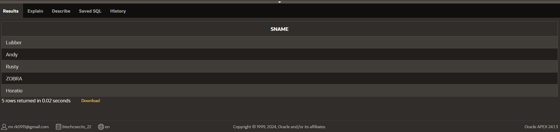

**Q-4.14 Display the orders made in the month of June**

* SELECT * FROM Salesorder WHERE EXTRACT(MONTH FROM TO_DATE(O_data, 'DD-MON-YY')) = 6;

**Q-4.15 List all the accounts created in the month of March.**

* SELECT * FROM Deposit WHERE EXTRACT(MONTH FROM TO_DATE(Date_, 'DD MON-YY')) = 3;

**Practical-5 “Like” Queries**

**Q-5.1 Display all customers whose**

* SELECT*FROM Customers WHERE Cname LIKE ('M%');

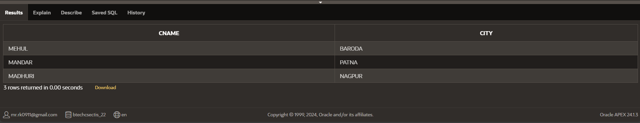

**Q-5.2 Display all the customers whose**

* SELECT*FROM Customers WHERE Cname LIKE ('%L');

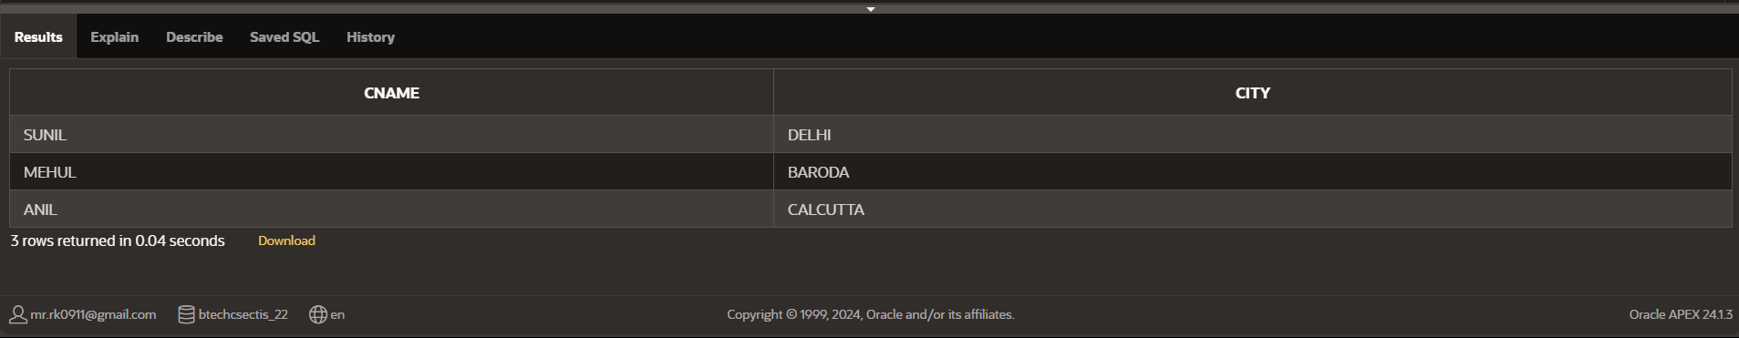

**Q-5.3 Display all loans details whoes branch starts with ‘A’.**

* SELECT*FROM Borrow WHERE Bname LIKE ('A%');

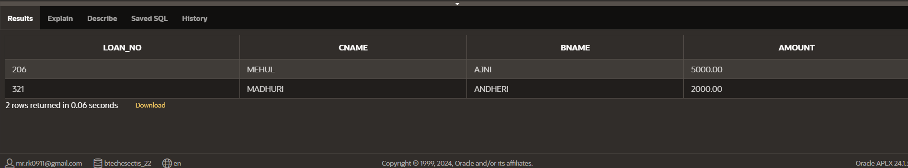

**Q-5.4 Display the details of sailors whose name is minimum 6 characters long**

* SELECT*FROM Sailors WHERE LENGTH (Sname)<6

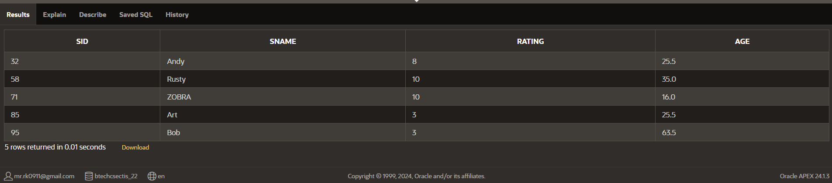

**Q-5.5 Display the details of employees whose address start with ‘S’**

* SELECT*FROM Employees WHERE City LIKE ('S%');

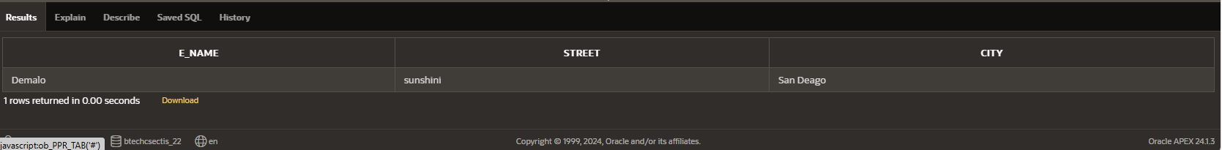

**Q-5.6 List the details of the boat ending with ‘e’**

* SELECT*FROM Boats WHERE Bname LIKE ('%e');

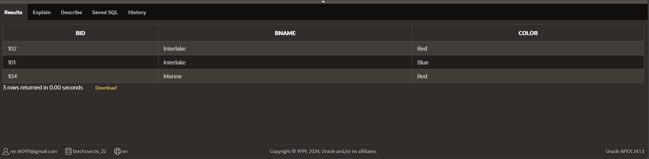

**Q-5.7 List the details of clients having ‘h’ as a 3 rd character in his/her name.**

* SELECT * FROM Client WHERE Name LIKE '__h%';

**Q-5.8 List client name,due balance and city whose pin code starts with 4.**

* SELECT Name, Baldue, City FROM Client where pincode LIKE('4%');

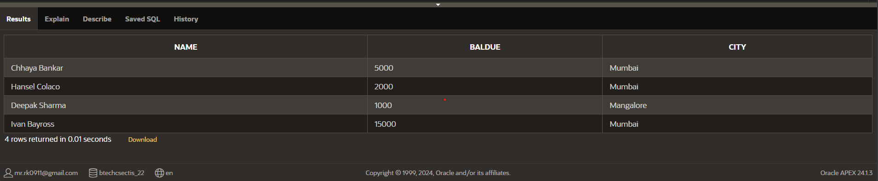

**Q-5.9 List all customers whose city contains ‘a’ as**

* SELECT * FROM Customers WHERE City LIKE '_A%';

**Q-5.10** List client names and city whose state has ‘a’ as fourth or fifth character.

* SELECT Name,City FROM Client WHERE STATE LIKE '__a%' OR STATE LIKE '___a%';

**Practical-6 “aggregate function & DML” queries**

**Q-6.1 List total deposit from deposit**.

* SELECT SUM(Amount) AS Amount FROM Deposit;

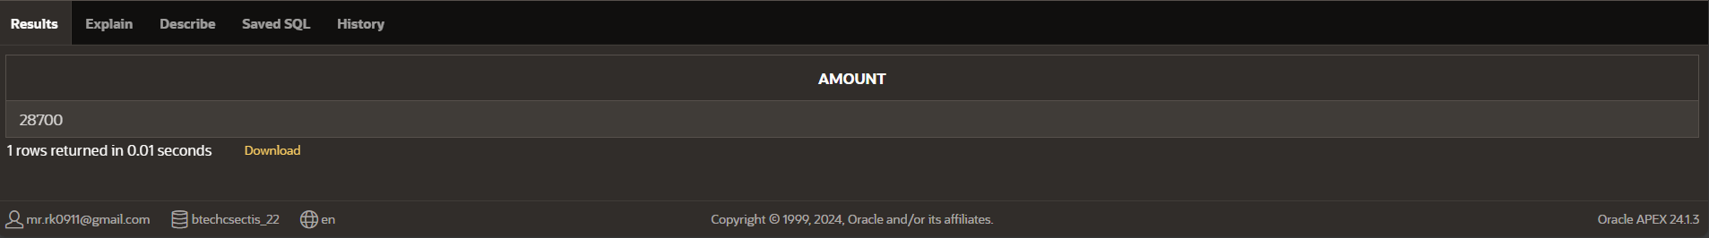

**Q-6.2 Give maximum loan given to the customer**

* SELECT MAX(Amount) AS Amount FROM Borrow;

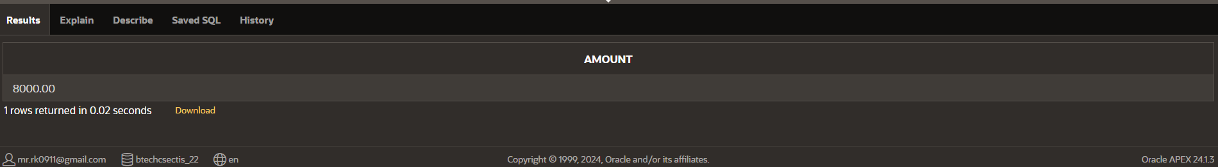

**Q-6.3 Describe the average age of**

* SELECT AVG(Age) AS Age FROM Sailors;

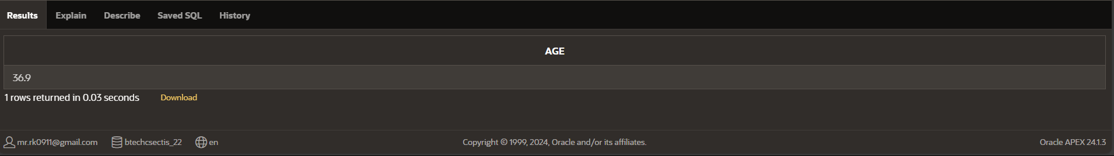

**Q-6.4 Count total number of customers.**

* SELECT COUNT(*) AS Cname FROM Customers;

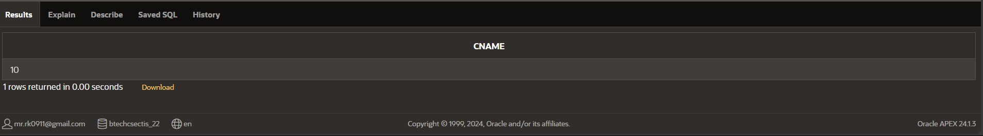

**Q-6.5 Count total number of customer cities**

* SELECT COUNT(DISTINCT CITY) AS TOTAL_CITIES FROM Customers;

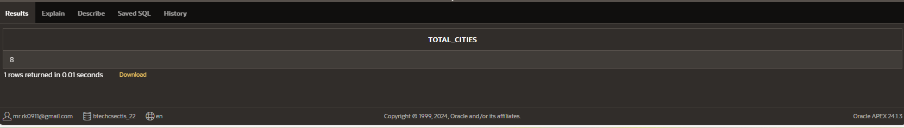

**Q-6.6(1) Display total target for the salesman**

* SELECT SUM(Tgt) AS Tgt FROM Salesman;

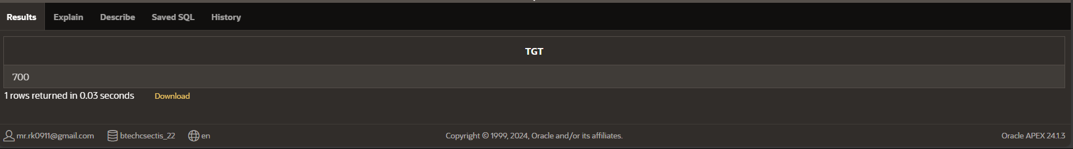

**Q-6.6(2) Update the salary of the employees having 10000 to 11500.**

* UPDATE Work SET Salary=11500 WHERE Salary=10000;

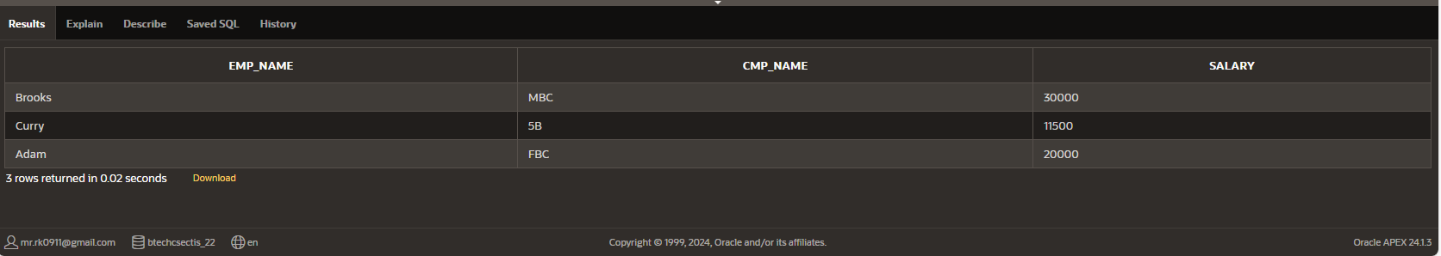

**Q-6.7 Update the city of client from bangalore to bengaluru.**

* UPDATE Client SET City='Bengaluru' WHERE City='Bangalore';

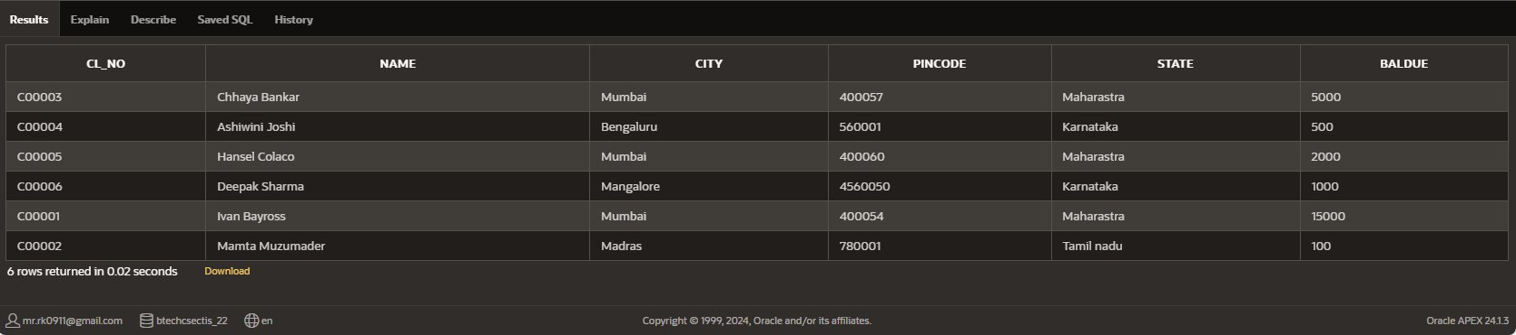

**Q-6.8 Give the 15% hike in the salary of the employees.Rename that column to “New salary”.**

* SELECT Salary * 1.15 AS "New Salary" from Work;

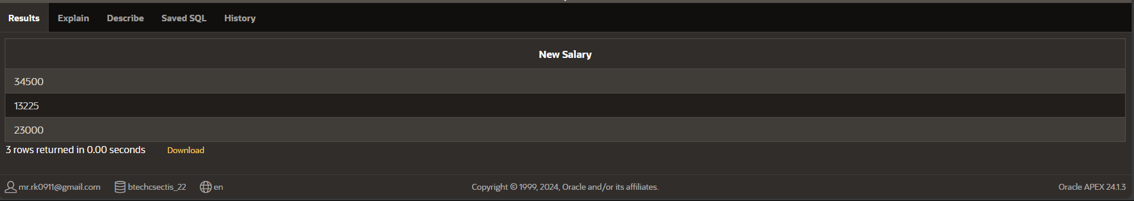

**Q-6.9 Increase the sell price of all products by 20% and label new column as “New sell price”.**

* SELECT sell_price *1.2 AS "New sell price"FROM product;

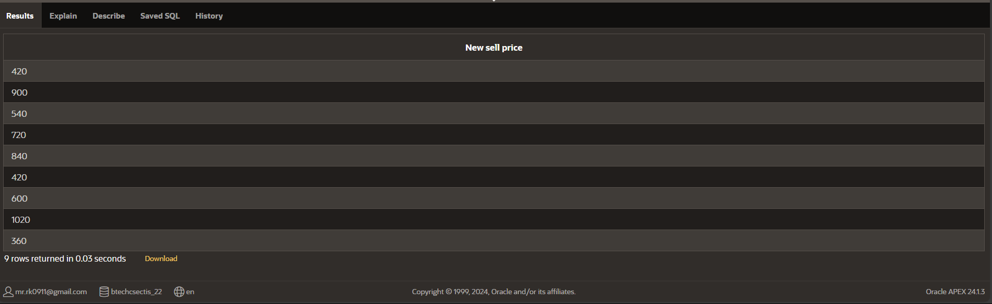

**Q-6.10 Provide the count of customers staying in “bombay”**

* SELECT count (*)FROM customers WHERE city='BOMBAY'

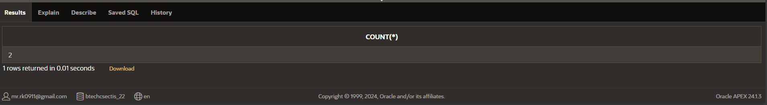

**Practical-7 “Join” Queries**

**Q-7.1 Find the salary of Adam.**

🡪 SELECT Salary FROM Work WHERE Emp_name = 'Adam';

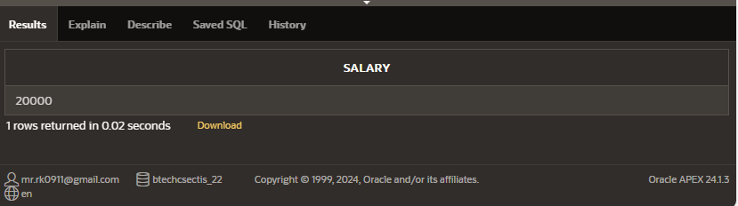

**Q-7.2 Find the city where Brooks work**

* SELECT City FROM Employee JOIN Work ON Employee.Emp_name = Work.Emp_name WHERE Work.Emp_name = 'Brooks';

**Q-7.3 Display the sailor’s details whose boat is booked for 9th May, 98.**

* SELECT s.Sid, s.Sname, s.Rating, s.Age FROM Sailors s JOIN Reserves r ON s.Sid = r.Sid WHERE TO_DATE(r.Day, 'DD-MON-YY') = TO_DATE('09-MAY-98', 'DD-MON-YY');

**Q-7.4 Display the day of ride and sailor name for boat 103.**

* SELECT R.Day, S.Sname FROM Reserves R JOIN Sailors S ON R. Sid = S. Sid WHERE R. Bid = 103;

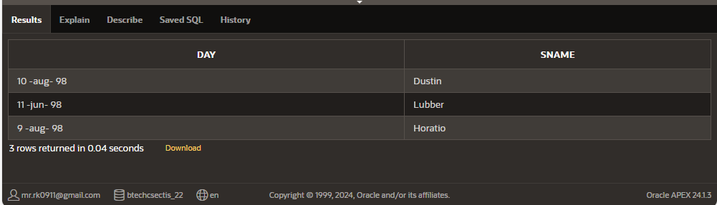

**Q-7.5 Display the sailor name and its age for Red colored and 101 boat.**

* SELECT S. Sname, S. Age FROM Sailors S JOIN Reserves R ON S. Sid = R. Sid JOIN Boats B ON R. Bid = B. Bid WHERE B. Color = 'Red' OR B. Bid = 101;

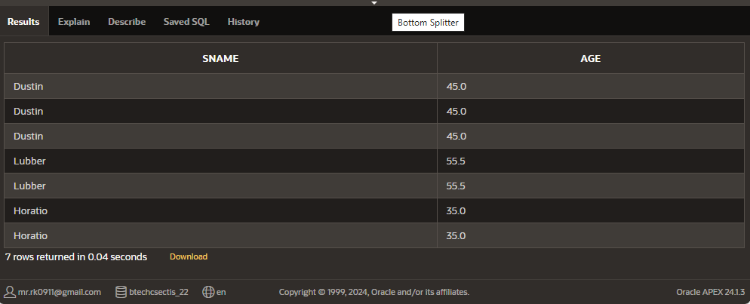

**Q-7.6 Display the sailor details whose boat is never booked.**

* SELECT S.* FROM Sailors S LEFT JOIN Reserves R ON S. Sid = R. Sid WHERE R. Sid IS NULL;

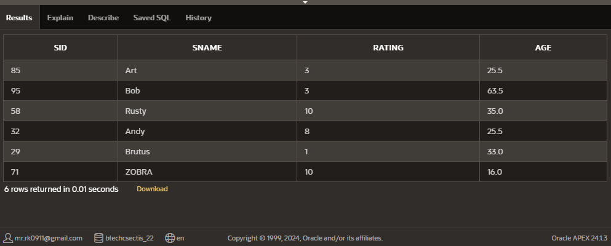

**Q-7.7 Display the sailor name that has Red or Green Boat.**

* SELECT DISTINCT S. Sname FROM Sailors S JOIN Reserves R ON S. Sid = R. Sid JOIN Boats B ON R. Bid = B. Bid WHERE B. Color IN ('Red', 'Green');

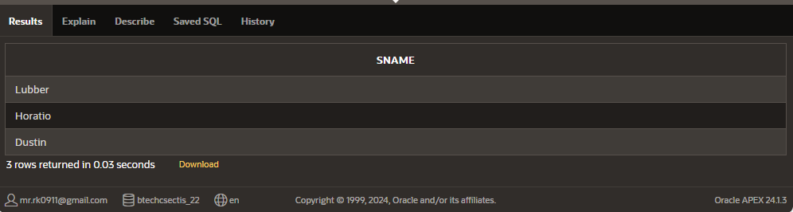

**Q-7.8 Display all sailor details and boat details and who has Interlake boat.**

* SELECT S.*, B.* FROM Sailors S JOIN Reserves R ON S. Sid = R. Sid JOIN Boats B ON R. Bid = B. Bid WHERE B. Bname = 'Interlake';

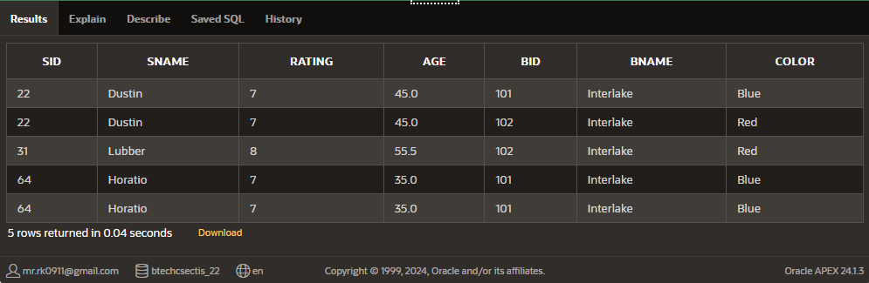

**Q-7.9 Display sailor’s rating with boat details or the trip on 10th October, 98.**

* SELECT s.Sname, s.Rating, r.Bid, r.Day FROM Sailors s JOIN Reserves r ON s.Sid = r.Sid WHERE TO_DATE(r.Day, 'DD-MON-YY') = TO_DATE('10-OCT-98', 'DD-MON-YY');

**Q-7.10 Display the sailor id and name whose age is more than 42 or who has Blue colored boat.**

* SELECT S. Sid, S. Sname FROM Sailors S JOIN Reserves R ON S. Sid = R. Sid JOIN Boats B ON R. Bid = B. Bid WHERE S. Age > 42 OR B. Color = 'Blue';

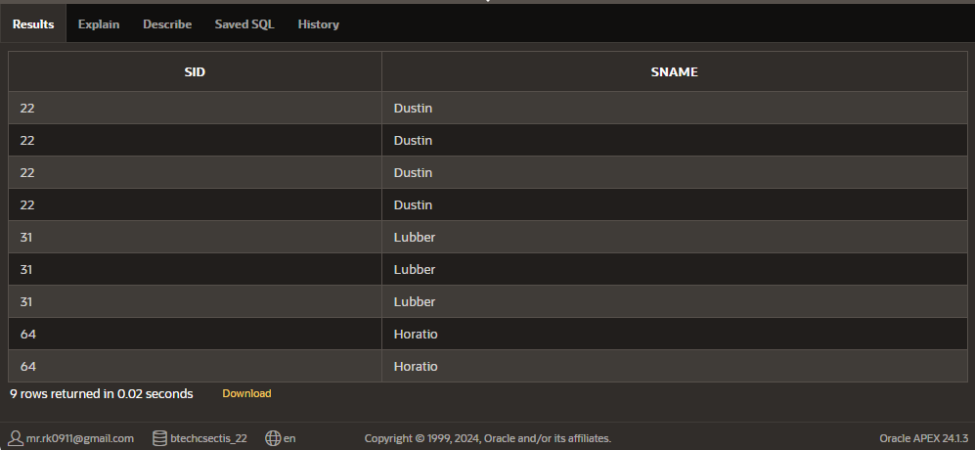

**Q-7.11 Display name and rating of sailor whose boat name is Clipper.**

* SELECT S. Sname, S. Rating FROM Sailors S JOIN Reserves R ON S. Sid = R. Sid JOIN Boats B ON R. Bid = B. Bid WHERE B. Bname = 'Clipper';

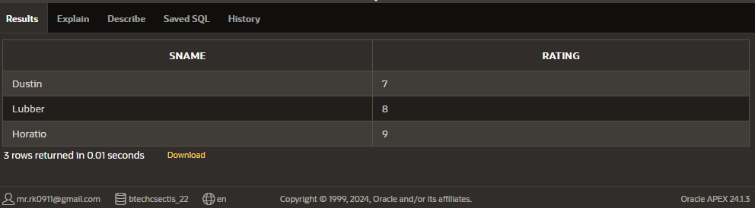

**Q-7.12 list products whose selling price is more than 500 and less than equal to 750.**

* SELECT DSCR, Sell_Price FROM Product WHERE Sell_Price > 500 AND Sell_Price <= 750;

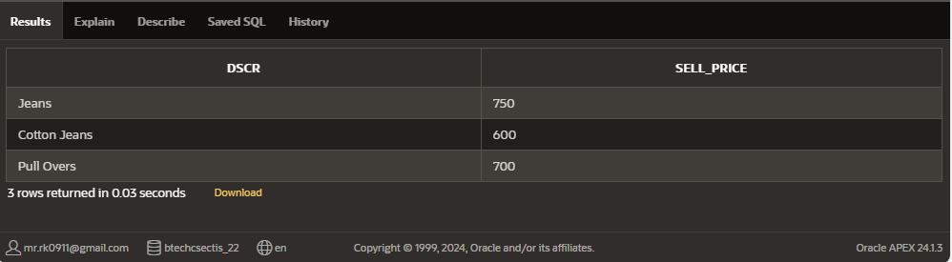

**Q-7.13 Describe the second highest salary of an employees.**

* SELECT MAX(Salary) AS Second_Highest_Salary FROM Work WHERE Salary < (SELECT MAX(Salary) FROM Work);

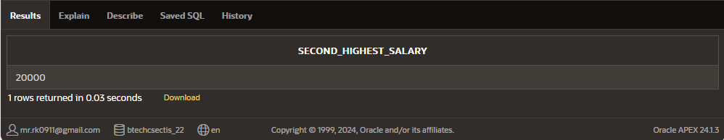

**Q-7.14 Display the date of travel and sailor’s name whose age is between 35 and 65**

* SELECT R. Day AS Date_Of_Travel, S. Sname AS Sailor_Name FROM Sailors S JOIN Reserves R ON S. Sid = R. Sid WHERE S. Age BETWEEN 35 AND 65;



**Q-7.15 List all the employees working for “FBC”.**

* SELECT E. Emp_name, E. Street, E. City FROM Employee E JOIN Work W ON E. Emp_name = W. Emp_name WHERE W. Cmp_name = 'FBC';

**Practical-8 “Join” Queries**

**Q-8.1 Display all the employee name and the city where they work.**

* select E_name , City from Employees;

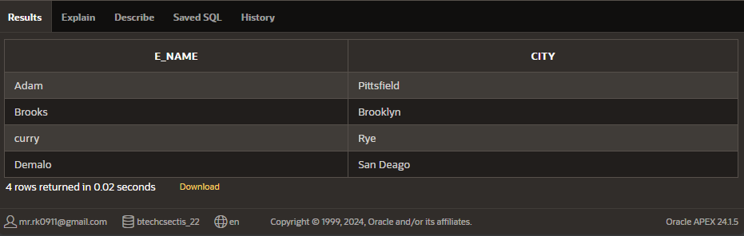

**Q-8.2 Display the employee name and company’s name having salary more than 15000.**

* select Emp_name,Cmp_name from Work where New_salary>15000;

**Q-8.3 Find the average rating and age of all sailors.**

* select avg(Rating),avg(Age) from Sailors;

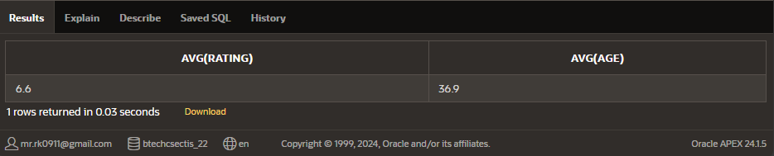

**Q-8.4 List various products available.**

* select dscr from Product;

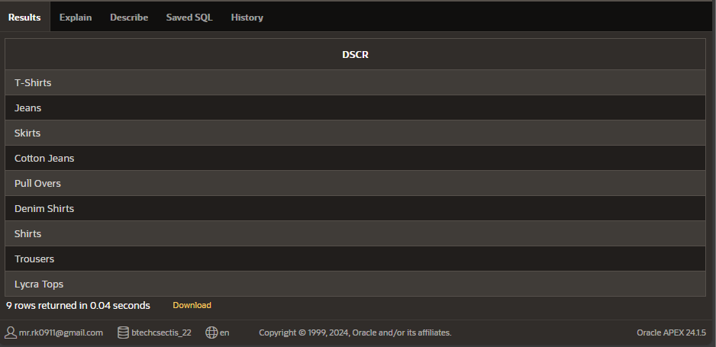

**Q-8.5 Display the names of salesman who have salary more than 2850.**

* SELECT Name FROM Salesman WHERE Amt>2850;

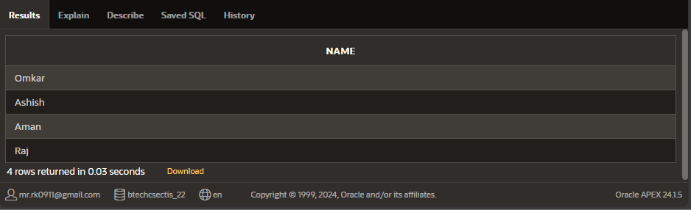

**Q-8.6 Change the cost price of Trousers to 950**

* update Product set Cost_price=950 where Dscr='Trousers';

select Dscr,Cost_price from Product where Dscr='Trousers';

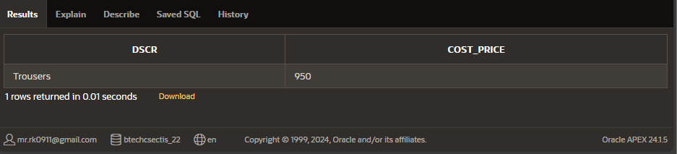

**Q-8.7 List all the clients having “a” as a second character in their names**

* SELECT Name FROM Client WHERE Name LIKE '_a%'

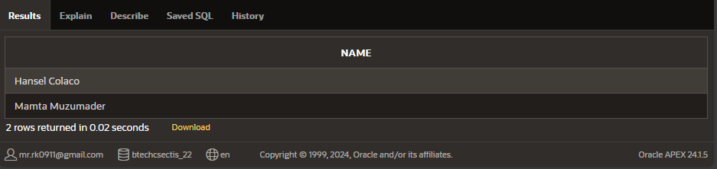

**Q-8.8 List all the products whose QtyonHand is less than Reorderlvl.**

* SELECT Dscr FROM Product WHERE Qty < Reorder_lv1;

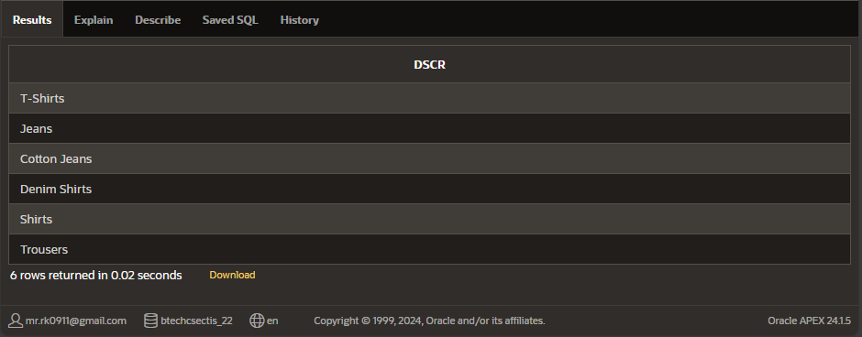

**Q-8.9 Print the description and total qty sold for each product.**

* SELECT P.Dscr, SUM(CAST(S.Qty_order AS INTEGER)) AS Total_Qty_Sold FROM Salesorder_Details S JOIN Product P ON S.Pr_no = P.Pr_no GROUP BY P.Dscr;

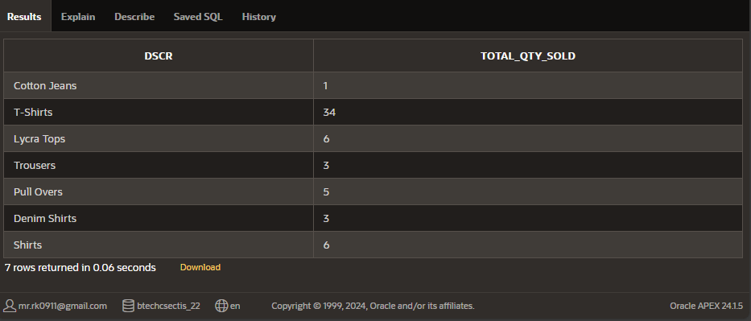

**Q-8.10 Find out all the products which have been sold to “Ivan Bayross”.**

* SELECT P.Dscr, O.Qty_order FROM Client C JOIN Salesorder S ON C.Cl_no = S.Cl_no JOIN Salesorder_Details O ON S.Od_no = O.Od_no JOIN Product P ON O.Pr_no = P.Pr_no WHERE C.Name = 'Ivan Bayross';

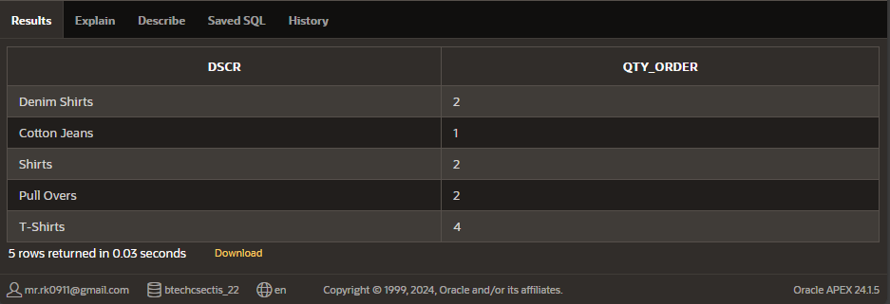

**Q-8.11 Find the names of all clients who have purchased Trousers.**

* SELECT C.name FROM Client C, Product P, Salesorder S, Salesorder_Details O WHERE C.CL_NO=S.CL_NO and S.OD_NO=O.OD_NO and P.PR_NO=O.PR_No and P.DSCR='Trousers' ;

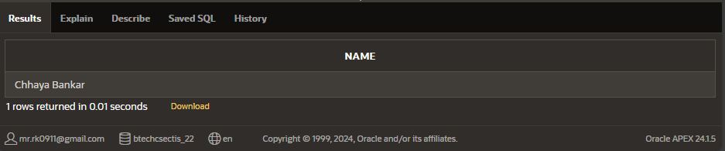

**Q-8.12 Find the products and their quantities for the orders placed by client C00001 and C00002**

* SELECT distinct S.Cl_no,P.DSCR,sum(O.Qty_Order) Total_Qty_Order FROM Client C, Product P, Salesorder S, Salesorder_Details O WHERE P.Pr_no=O.Pr_no and O.Od_no=S.Od_no and S.Cl_no='C00001' or S.Cl_no='C00002' group by P.DSCR,P.Pr_no,S.Cl_no;

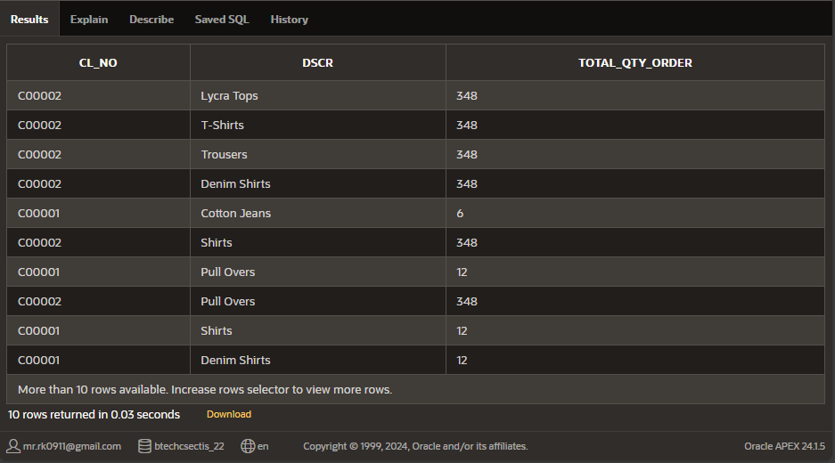

**Q-8.13 List the client details who place order no. O19001**

* SELECT C.* FROM Client C, Salesorder S where C.Cl_no=S.Cl_no and S.Od_no='O19001';

**Q-8.14 List the client details who place order no. O19001**

* SELECT distinct C.name FROM Client C, Salesorder S, Salesorder_Details O WHERE C.Cl_no=S.Cl_no and S.Od_no=O.Od_no and C.Cl_no=S.Cl_no and (O.Qty_Order*O.Rate)>10000;

**Q-8.15 Find the total of Qty ordered for each Order.**

* select Od_no, sum(Qty_order) from Salesorder_Details group by Od_no;

**PRACTICAL– 9 “Miscellaneous” Queries**

**Q-9.1 Find the average rate for each Order**

* SELECT avg(Rate) AS AVERAGE_RATE FROM Salesorder_Details;

**Q-9.2 Give the loan details of all the customers.**

* SELECT * FROM Borrow;

**Q-9.3 List the customer name having loan account in the same branch city they live in**

* SELECT c.Cname, br.City AS Branch_City, c.City AS Customer_City FROM Borrow b JOIN Branch br ON b.Bname = br.Bname JOIN Customers c ON c.Cname = b.Cname;

**Q-9.4 Provide the loan details of all the customers who have opened their accounts after August’95**

* SELECT * FROM Deposit WHERE Dates > To_DATE(‘31-AUG-95’,’DD-MON-YY’);

**Q-9.5 List the order information for client C00001 and C00002.**

* SELECT * FROM Salesorder WHERE Cl_no IN ('C00001', 'C00002');

**Q-9.6 List all the information for the orders placed in the month of June.**

* SELECT * FROM Salesorder WHERE TO_DATE(O_data, 'DD-MON-YY') BETWEEN TO_DATE('01-JUN-04', 'DD-MON-YY') AND TO_DATE('30-JUN-04', 'DD-MON YY');

**Q-9.7 List the details of clients who do not stay in Maharashtra.**

* SELECT * FROM Client WHERE State! = 'Maharashtra';

**Q-9.8 Determine the maximum and minimum product price. Rename the output as “Max_Price” and “Min_Price”.**

* SELECT MAX(Sell_price) AS Max_Price, MIN(Sell_price) AS Min_Price FROM Product;

**Q-9.9 Count the number of products having price less than or equal to 500.**

* SELECT COUNT (*) AS Count_Low_Priced_Products FROM Product WHERE Sell_price <= 500;

**Q-9.10 List the order number and the day on which client placed an order**

* SELECT Od_no,TO_CHAR(TO_DATE(O_data, 'DD-MON-YY'), 'DD') AS Order_Day FROM Salesorder;

**Q-9.11 List the month and the date on which an order is to be delivered.**

* SELECT TO_CHAR (TO_DATE (O_data, 'DD-MON-YY'), 'MONTH') AS Delivery_Month,TO_CHAR(TO_DATE(O_data, 'DD-MON-YY'), 'DD') AS Delivery_Date FROM Salesorder;

**Q-9.12 List the date, 25 days after today’s date.**

* SELECT SYSDATE + 25 AS Date_After_25_Days FROM dual;

**Q-9.13 Find the total of all the billed orders in the month of June.**

* SELECT SUM(SD.Qty_order * SD.Rate) AS Total_Billed_Orders FROM Salesorder S JOIN Salesorder_Details SD ON S.Od_no = SD.Od_no WHERE EXTRACT(MONTH FROM TO_DATE(S.O_data, 'DD-MON-YY')) = 6;

**Q-9.14 List the products and orders from customers who have ordered less than 5 units of “Pull Overs”.**

* SELECT P.Dscr, O.Od_no FROM Salesorder_Details O JOIN Product P ON O.Pr_no = P.Pr_no WHERE P.Dscr = 'Pull Overs' AND O.Qty_order < 5;

**Q-9.15 Find the list of products and orders placed by “Ivan Bayrosss” and “Mamta Muzumdar”.**

* SELECT O.Od_no, P.Dscr FROM Salesorder O JOIN Salesorder_Details D ON O.Od_no = D.Od_no JOIN Product P ON D.Pr_no = P.Pr_no WHERE O.Cl_no IN ('C00001', 'C00002');

**Q-9.16 List the clients who placed order before June’04.**

* SELECT DISTINCT c.Cl_no, c.Name FROM Client c JOIN Salesorder s ON c.Cl_no = s.Cl_no WHERE EXTRACT(MONTH FROM TO_DATE(s.O_data, 'DD-MON-YY')) < 6 AND EXTRACT(YEAR FROM TO_DATE(s.O_data, 'DD-MON-YY')) = 2004 OR EXTRACT(YEAR FROM TO_DATE(s.O_data, 'DD-MON-YY')) < 2004;

**Q-9.17 List all the clients who stays in “Bengaluru” or “Mangalore”.**

* SELECT * FROM Client WHERE City IN ('Bangalore', 'Mangalore');

**PRACTICAL – 10 – “PL/SQL Block”**

**Q-10.1 Write a PL/SQL Block to Add 2 Numbers**

* Declare

x number (5);

y number (5);

z number (7);

begin

x: =10;

y: =20;

z: =x+y;

DBMS_OUTPUT.PUT_LINE ('Sum is '||z);

end;

**Q-10.2 Write a PL/SQL Block to find Area of Rectangle, Triangle and Square.**

* declare

area_c number (6, 2);

radius number (1): = 3;

area_r number (6);

area_s number (6);

length number (2): = 5;

width number (2): = 4;

pi constant number (3, 2): = 3.14;

begin area_c := pi * radius * radius;

DBMS_OUTPUT.PUT_LINE ('Circle area = ' || area_c);

area_r := length * width;

DBMS_OUTPUT.PUT_LINE ('Rectangle area = ' || area_r);

area_s := length * length;

DBMS_OUTPUT.PUT_LINE ('Square area = ' || area_s);

end;

**Q-10.3 Write a PL/SQL Block to find Maximum of 3 numbers**

* DECLARE

x NUMBER (5);

y NUMBER (5);

z NUMBER (5);

max_value NUMBER (5);

BEGIN x: = 10; y: = 20; z: = 15;

-- Determine the maximum of x, y, and z

max_value: = x; -- Assume x is the maximum initially

IF y > max_value THEN

max_value: = y; -- Update max_value if y is greater

END IF;

IF z > max_value THEN

max_value: = z; -- Update max_value if z is greater

END IF;

DBMS_OUTPUT.PUT_LINE ('The maximum value is: ' || max_value);

END;

**Q-10.4 Write a PL/SQL Block to print sum of N Numbers using For Loop**

* DECLARE

n NUMBER: = 10; -- Change this value to sum up to a different number

sum_value NUMBER: = 0; -- Variable to store the sum

BEGIN -- Loop from 1 to n

FOR i IN 1. n LOOP

sum value: = sum_value + i; -- Add the current value of i to sum_value

END LOOP;

-- Print the result using

APEX_OUTPUT APEX_DEBUG.MESSAGE('The sum of the first ' || n || ' numbers is: ' || sum_value);

END;

**Q-10.5 Write a PL/SQL Block to generate Fibonacci series of N numbers**

* DECLARE

n NUMBER: = 10; -- Change this value to generate more or fewer Fibonacci numbers

a NUMBER: = 0; -- First Fibonacci number

b NUMBER: = 1; -- Second Fibonacci number

c NUMBER; -- Next Fibonacci number

BEGIN -- Output the first two Fibonacci numbers

APEX_DEBUG.MESSAGE('Fibonacci Series:');

APEX_DEBUG.MESSAGE(a); -- Output first number

APEX_DEBUG.MESSAGE(b); -- Output second number

-- Loop to generate the Fibonacci series

FOR i IN 3 ... n LOOP

c: = a + b; -- Calculate next number in the series

APEX_DEBUG.MESSAGE(c); -- Output the next Fibonacci number

a: = b; -- Update a to the previous b

b: = c; -- Update b to the new Fibonacci number

END LOOP;

END;

